**WEB BASED STOREFRONT**

**A PROJECT REPORT**

***Submitted by :***

Abhik Gupta (09514902021)

John P Varghese (04714902021)

Yatin Hooda (02914902021)

Nishchay Chandok (35914902021)

***In partial fulfillment for the award of the degree***

***of***

**BACHELOR OF COMPUTER APPLICATION**



**MAHARAJA SURAJMAL INSTITUTE**

**C4, JANAKPURI, NEW DELHI – 110058**

**DECEMBER 2023**

**DECLARATION**

We affirm that this submission is the result of our individual effort, and we attest that, to the best of our knowledge and belief, it does not incorporate any material previously published or authored by another individual. Furthermore, we confirm that this work has not been utilized in whole or in part for the completion of any other academic degree or diploma from any university or educational institution. Any instances where external contributions have been acknowledged are duly cited within the text.

**Name:** Abhik Gupta

**Enrollment Number:** 09514902021

**Signature:**

**Date:**

**Name:** Yatin Hooda

**Enrollment Number:** 02914902021

**Signature:**

**Date:**

**Name:** John P Varghese

**Enrollment Number:** 04714902021

**Signature:**

**Date:**

**Name:** Nishchay Chandok

**Enrollment Number:** 35914902021

**Signature:**

**Date:**

**BONAFIDE CERTIFICATE**

I certify that the project report titled **"WEB BASED STOREFRONT"** is a bonafide, authentic and genuine work and hard work of the team comprising **“Abhik Gupta, John P Varghese, Yatin Hooda, and Nishchay Chandok”**. This team diligently conducted the project under my supervision, and I can attest to the integrity and originality of their work.

**SUPERVISOR**

Mr. Sundeep Kumar

Assistant professor

Dept. of Computer Application

**SIGNATURE OF SUPERVISOR**

**SELF CERTIFICATE**

This is to certify that the dissertation/project report entitled **“WEB BASED STOREFRONT”** is done by me is an authentic work carried out for the partial fulfilment of the requirements for the award of the degree of Bachelor of Computer Applications under the guidance of **“Mr. Sundeep Kumar”**. The matter embodied in this project work has not been submitted earlier for award of any degree or diploma to the best of my knowledge and belief.

ABHIK GUPTA

09514902021

**(TEAM LEADER)**

**ACKNOWLEDGEMENT**

Certified We would like to take this opportunity to acknowledge everyone who has helped us in every stage of this project.

We extend our heartfelt appreciation to all those who contributed to the successful realization of this project. A special acknowledgment goes to **Mr. Sundeep Kumar** from the **Department of Computer Science** for his invaluable guidance and insightful suggestions, which played a pivotal role in bringing this project to fruition. We are sincerely grateful for his unwavering support.

Furthermore, our sincere thanks go to our esteemed **Director, Dr. Harish Singh**, whose provision of essential facilities significantly contributed to the seamless completion of this project. We express our gratitude for his support and encouragement throughout the entire process.

ABHIK GUPTA

JOHN P VARGHESE

YATIN HOODA

NISHCHAY CHANDOK

**BCA 5A (MORNING)**

**TABLE OF CONTENTS**

|  |  |  |
| --- | --- | --- |
| **CHAPTER NO.** | **TITLE** | **PAGE NUMBER** |
|  | Synopsis   1. Objective 2. Scope 3. What is Vendr? 4. Why did we choose Vendr? | 1 - 3 |
|  | Requirements   * Hardware Requirements * Software Requirements | 4-5 |
|  | Abstract of the project. | 6 |
|  | Working of the application | 7 - 8 |
|  | Tech Stack being used   * Frontend * Backend | 9 - 15 |
|  | SRS   * Functional Requirements * Interface Requirements * Performance Requirements * Design Constraints * Non-Functional Attributes * Schedule and Plan | 16 - 19 |
|  | Software Design   * Level-0 DFD of project * Level-1 DFD of project * Use Case Diagram of project * ER Diagram of database structure | 20 - 28 |
|  | Team Description | 29 |
|  | Coding and Implementation | 30 - 124 |
|  | Output Screenshots | 125 - 135 |
|  | Version Control and Collaboration | 136 - 139 |
|  | Conclusion | 140 – 141 |
|  | Future Scope | 142 – 143 |
|  | References | 144 |

**SYNOPSIS**

**OBJECTIVE**

The objective of Vendr, a comprehensive e-commerce application developed using the MERN (MongoDB, Express.js, React.js, Node.js) stack, is to provide users with a seamless and intuitive platform for buying and selling goods online. By leveraging modern web development technologies such as React and Redux for the frontend, Node.js and Express for the backend, and MongoDB Atlas for cloud-based data storage, Vendr aims to deliver a highly responsive and scalable e-commerce experience. Integrating SquareUp for secure payment processing, nodemailer for efficient email communication, and JWT (JSON Web Tokens) along with passport for robust authentication, Vendr ensures a secure and reliable environment for both buyers and sellers.

**SCOPE**

The objective of Vendr, a comprehensive e-commerce application developed using the MERN (MongoDB, Express.js, React.js, Node.js) stack, is to provide users with a seamless and intuitive platform for buying and selling goods online. By leveraging modern web development technologies such as React and Redux for the frontend, Node.js and Express for the backend, and MongoDB Atlas for cloud-based data storage, Vendr aims to deliver a highly responsive and scalable e-commerce experience. Integrating SquareUp for secure payment processing, nodemailer for efficient email communication, and JWT (JSON Web Tokens) along with passport for robust authentication, Vendr ensures a secure and reliable environment for both buyers and sellers.

**SUMMARY**

Vendr is a feature-rich e-commerce application designed to streamline the online shopping experience for both buyers and sellers. Leveraging the power of the MERN stack, Vendr offers a responsive and scalable platform that caters to the diverse needs of modern e-commerce. With secure authentication mechanisms, robust payment processing, and efficient email functionality, Vendr prioritizes user security and satisfaction. Whether it's browsing through a vast array of products, making secure transactions, or managing orders with ease, Vendr provides a comprehensive solution for all e-commerce requirements. By harnessing cutting-edge technologies and adhering to best practices, Vendr sets a new standard for online retail platforms, promising a seamless and enjoyable shopping experience for users worldwide.

**WHAT IS VENDR ?**

Vendr is a dynamic and fully functional e-commerce application crafted to revolutionize the online shopping experience. At its core, Vendr is a sophisticated platform that connects buyers and sellers in a seamless digital marketplace. Built using the MERN (MongoDB, Express.js, React.js, Node.js) stack, Vendr boasts a modern and intuitive user interface powered by React and Redux, ensuring a smooth and responsive browsing experience. With Express.js handling API requests and MongoDB Atlas providing a secure cloud-based database solution, Vendr offers a robust infrastructure that supports the entire e commerce process, from product discovery to order fulfillment. By integrating SquareUp for secure payment processing, nodemailer for efficient email communication, and JWT with passport for authentication, Vendr prioritizes user security and satisfaction, setting a new standard for online retail platforms.

**WHY DID WE CHOOSE VENDR?**

Vendr was chosen as a project for its potential to address the growing demand for innovative e-commerce solutions. In today's digital age, online shopping has become an integral part of daily life for millions worldwide. However, existing e-commerce platforms often lack the customization, security, and scalability needed to meet the evolving needs of both buyers and sellers. By developing Vendr, we aimed to fill this gap by creating a comprehensive e-commerce solution that leverages cutting-edge technologies and best practices. Vendr's modular architecture and extensive feature set make it an ideal choice for businesses looking to establish or enhance their online presence. Moreover, by open-sourcing Vendr, we encourage collaboration and contribution from the developer community, fostering innovation and continuous improvement in the realm of e-commerce technology. Ultimately, choosing Vendr as a project aligns with our commitment to delivering impactful and scalable solutions that empower businesses and elevate the online shopping experience for consumers worldwide.

**REQUIREMENTS**

**HARDWARE REQUIREMENTS**

1. Servers with adequate CPU, RAM, and storage resources to accommodate anticipated traffic and data storage needs.
2. Reliable network infrastructure including routers, switches, and firewalls for seamless communication.
3. Consideration of a load balancer for distributing incoming requests across multiple servers, particularly for scalability.
4. Compatibility with hardware associated with integrated payment gateways like SquareUp, such as card readers or terminals.

**SOFTWARE REQUIREMENTS**

1. Compatible operating system (e.g., Linux, Windows Server) installed on servers.
2. Node.js and npm (Node Package Manager) for running the backend application.
3. MongoDB for database management, either installed locally or hosted on MongoDB Atlas.
4. Express.js for building backend APIs and handling HTTP requests.
5. React and Redux libraries for frontend development, ensuring interactive user interfaces and efficient state management.
6. Integration of SquareUp SDK for secure payment transactions.
7. Nodemailer for handling email functionalities such as sending order confirmations and notifications.
8. Authentication managed using JWT (JSON Web Tokens) and Passport.js.
9. Deployment facilitated by tools like Vercel or Docker for production environments.
10. Implementation of monitoring and logging tools for tracking application performance and troubleshooting issues effectively.
11. This combination of hardware and software provides a robust infrastructure capable of supporting the complex requirements of modern e-commerce application development, ensuring that the team can develop, test, and deploy efficiently and effectively.

**ABSTRACT**

Embarking on the Vendr project has been an exhilarating journey into the heart of e-commerce innovation. Vendr stands as a testament to our dedication to crafting a cutting-edge platform that redefines the online shopping experience. Leveraging the power of the MERN (MongoDB, Express.js, React.js, Node.js) stack, Vendr represents a fusion of modern technology and user-centric design, aimed at empowering both buyers and sellers in the digital marketplace.

At its core, Vendr embodies a comprehensive suite of features meticulously crafted to meet the diverse needs of our users. With a strong emphasis on scalability, security, and seamless functionality, Vendr offers an intuitive platform for browsing, purchasing, and managing products effortlessly. From secure user authentication to efficient order processing, every aspect of Vendr is designed to enhance the user experience and drive business growth.

As we continue to refine and expand Vendr, our vision extends beyond mere transactions to fostering meaningful connections and experiences. Future enhancements such as multi-vendor support, social commerce integration, and personalized recommendations exemplify our commitment to staying at the forefront of e-commerce innovation. With Vendr, we are not just building a platform; we are shaping the future of online retail, one innovative feature at a time.

**WORKING OF THE APPLICATION**

1. Vendr prioritizes users and works on a User Centric mode.
2. Users can start with a smooth sign-up process where they are needed to provide essential details like email and password on the Sign Up Page.
3. Upon successful registration, users are automatically logged in. Returning users can log in through the Login Page, where they enter their email and password for secure login using JWT and PassportJS for end-to-end encryption and authentication.
4. The user interface is intuitive after logging in.
5. Users are greeted with a product listing page showcasing a variety of products across categories and brands. For a large number of products, the application presents a paginated view.
6. Users can sort results based on price and ratings.
7. Users can also categorize items based on product category or brand.
8. Two additional pages are accessible through the Navbar: "About Us" and "Contact Us." The "About Us" page is a static page with a brief application description. The "Contact Us" page has a form with a single input field for users to enter their queries to be sent to admins.
9. To purchase a product, users click on the desired item, which opens the product description page.
10. The product description page offers a detailed view, including highlights, description, price, ratings, multiple images, and available sizes and colors.
11. Users can simply choose a color and size and click "Add to Cart" to add the product to their cart.
12. After adding products, users can access the cart through the cart button in the Navbar for a final review before checkout.
13. On the cart page, users can modify the quantity of an item or even remove it entirely from the cart.
14. Once users finalize their cart, they can proceed to checkout by clicking the checkout button.
15. The checkout page offers a form at the top to add a delivery address if not already provided. Once an address is added, users can select it from their saved addresses and choose a payment method.
16. Two payment methods are available: Cash and Card. Cash payments confirm the order immediately. Card payments open a dedicated payment gateway to complete the transaction and confirm the order upon successful payment.
17. Upon successful order placement, an invoice with the product list, subtotal, and individual product prices is sent to the email address provided during checkout.
18. Once the order is confirmed, users can view a detailed view of the order from the "My Orders" page accessible through the User Icon at the top right. This page displays the order, subtotal, total number and description of products ordered, along with the order status.
19. The User Icon at the top right also provides access to the "My Profile" page where users can view their saved email, phone number, and addresses, and even edit or remove this data.
20. Users can log out of the application by clicking the User Icon at the top right and then selecting "Sign Out."
21. The application also provides an "Admin Panel" accessible through an Admin account login.
22. Upon logging in with an Admin account, the admin can perform everything a regular user can, such as purchasing items, viewing the "My Profile" page, or viewing the "My Orders" page. However, the Admin Panel has three additional options: "Admin Products," "Admin Orders," and "Admin Queries."
23. The "Admin Products" page displays the entire product listing with an "Edit Product" button for each product. Clicking this button opens a page form where the admin can edit product details. The "Admin Products" page also has an "Add Product" button at the top, which opens a form page for the Admin to add a new product.
24. The "Admin Orders" page displays all orders created by various users, along with each order's ID, purchased items, payment method, delivery address, payment status, and order status. The Admin can also update the Order status and Payment status of any order from this page.
25. The "Admin Queries" page displays all queries submitted by regular users through the "Contact Us" section.
26. If a user or admin forgets their password while logging in, they can simply click the "Forgot Password Button" on the Login Page. Here, they can enter their email address, and an email will be sent with a link that brings the user back to the application to set a new password, which ultimately changes the user's password upon submission.

**TECH STACK USED FOR DEVELOPMENT**

**PROJECT STRUCTURE:**

1. **Client-Side (Frontend):**
   1. Developed using React, React Router DOM, and various UI libraries like Tailwind for enhanced functionality and user experience.
   2. Used React Redux to handle states and a store to manage the application’s frontend organized and feature-rich.
2. **Server-Side (Backend):**
   1. Built on Node.js and Express, facilitating the creation of a scalable and efficient server.
   2. Utilizes MongoDB as the database, with Mongoose for data modeling and interactions.
   3. Employs Babel for ECMAScript compatibility and provides additional middleware for features like compression, CORS, and validation.
3. **Note:**
   1. The technology stack combines the strengths of React and Redux for the dynamic frontend, Node.js and Express for the robust backend, MongoDB for flexible and scalable data storage, and various libraries and tools to enhance functionality, security, and development efficiency. This stack ensures a modern, efficient, and scalable architecture for the Vendr project.

**FRONTEND DEPENDENCIES (CLIENT):**

1. **@headlessui/react**

* Version: ^1.7.18
* Description: @headlessui/react is a library that provides accessible and composable React components for building user interfaces without styling constraints.

1. **@heroicons/react**

* Version: ^2.1.3
* Description: @heroicons/react offers a set of customizable React components for incorporating Heroicons, a collection of free SVG icons, into your React applications.

1. **@reduxjs/toolkit**

* Version: ^1.9.7
* Description: @reduxjs/toolkit is a package that simplifies Redux usage by providing utilities for writing Redux logic, including reducers, actions, and middleware, in a more efficient and ergonomic manner.

1. **@stripe/react-stripe-js**

* Version: ^2.7.0
* Description: @stripe/react-stripe-js facilitates integration with the Stripe payment platform in React applications, allowing for secure and seamless payment processing.

1. **@stripe/stripe-js**

* Version: ^3.3.0
* Description: @stripe/stripe-js is the Stripe JavaScript library for handling client-side interactions with Stripe, such as creating payment methods and handling card validations.

1. **@tailwindcss/aspect-ratio**

* Version: ^0.4.2
* Description: @tailwindcss/aspect-ratio is a Tailwind CSS plugin that provides utilities for creating responsive aspect-ratio boxes, allowing for consistent sizing of elements based on aspect ratios.

1. **@tailwindcss/forms**

* Version: ^0.5.7
* Description: @tailwindcss/forms is a Tailwind CSS plugin that provides styles for form elements, such as input fields, checkboxes, and radio buttons, ensuring consistent and customizable form styling.

1. **@testing-library/jest-dom**

* Version: ^5.17.0
* Description: @testing-library/jest-dom offers Jest matchers for asserting expectations on DOM elements, making it easier to write and maintain test cases for React components.

1. **@testing-library/react**

* Version: ^13.4.0
* Description: @testing-library/react provides utilities for testing React components, including rendering components, interacting with them, and querying the DOM for testing purposes.

1. **@testing-library/user-event**
   * Version: ^14.5.2
   * Description: @testing-library/user-event offers utilities for simulating user interactions, such as clicking, typing, and navigating, in testing environments, allowing for comprehensive testing of user interactions in React components.
2. **json-server**

* Version: 0.17.0
* Description: json-server is a lightweight server that serves JSON data over HTTP, making it useful for mocking APIs and simulating backend services during development and testing.

1. **react**

* Version: ^18.2.0
* Description: React is a JavaScript library for building user interfaces, providing a declarative and component-based approach to building interactive web applications.

1. **react-dom**

* Version: ^18.2.0
* Description: react-dom is a package that provides DOM-specific methods for working with React components, enabling rendering of React applications in web browsers.

1. **react-hook-form**

* Version: ^7.51.3
* Description: react-hook-form is a library for building performant and flexible forms in React applications, offering hooks-based form validation and management capabilities.

1. **react-loader-spinner**

* Version: ^6.1.6
* Description: react-loader-spinner provides customizable loading spinners for React applications, offering visual feedback to users during asynchronous operations and data loading processes.

1. **react-redux**

* Version: ^8.1.3
* Description: react-redux is the official React bindings for Redux, enabling integration of Redux state management with React components, allowing for efficient and predictable management of application state.

1. **react-router-dom**

* Version: ^6.22.3
* Description: react-router-dom provides routing and navigation functionalities for React applications, allowing for declarative and dynamic routing of components based on URL paths.

1. **react-scripts**

* Version: 5.0.1
* Description: react-scripts is a set of scripts and configuration files for bootstrapping and running React applications, including development servers, build scripts, and testing utilities.

1. **react-square-web-payments-sdk**

* Version: ^3.2.1
* Description: react-square-web-payments-sdk facilitates integration with Square's Web Payments SDK in React applications, enabling secure and streamlined payment processing using Square's payment platform.

1. **react-toastify**

* Version: ^10.0.5
* Description: react-toastify provides toast notification capabilities for React applications, offering customizable and user-friendly notifications for displaying messages, alerts, and feedback to users.

1. **web-vitals**

* Version: ^2.1.4
* Description: web-vitals is a library for measuring and reporting essential performance metrics of web pages, including metrics such as First Contentful Paint (FCP), Largest Contentful Paint (LCP), and Cumulative Layout Shift (CLS).

**BACKEND DEPENDENCIES (SERVER):**

1. **cookie-parser**

* Version: ^1.4.6
* Description: cookie-parser is a middleware for parsing cookies in Express applications, enabling easy access to cookie data in request objects.

1. **cors**

* Version: ^2.8.5
* Description: cors is a middleware for enabling Cross-Origin Resource Sharing (CORS) in Express applications, allowing for controlled access to resources from different origins.

1. **dotenv**

* Version: ^16.4.5
* Description: dotenv is a module for loading environment variables from a .env file into Node.js applications, providing a convenient way to manage configuration settings.

1. **express**

* Version: ^4.19.2
* Description: express is a fast, unopinionated, and minimalist web framework for Node.js, providing a robust set of features for building web applications and APIs.

1. **express-session**

* Version: ^1.18.0
* Description: express-session is a middleware for managing session data in Express applications, enabling the creation and management of user sessions with session-based authentication.

1. **jsonwebtoken**

* Version: ^9.0.2
* Description: jsonwebtoken is a library for generating and verifying JSON Web Tokens (JWT) in Node.js applications, facilitating secure authentication and authorization mechanisms.

1. **mongoose**

* Version: ^8.3.2
* Description: mongoose is an Object Data Modeling (ODM) library for MongoDB and Node.js, providing a schema-based solution for modeling application data and interacting with MongoDB databases.

1. **nodemailer**

* Version: ^6.9.13
* Description: nodemailer is a module for sending email messages from Node.js applications, offering a simple and efficient API for configuring and sending emails via SMTP or other transport methods.

1. **nodemon**

* Version: ^3.1.0
* Description: nodemon is a utility for automatically restarting Node.js applications when file changes are detected, providing a convenient development workflow for server-side development.

1. **passport**

* Version: ^0.7.0
* Description: passport is an authentication middleware for Node.js applications, offering a flexible and modular approach to implementing authentication strategies, such as OAuth, JWT, and local authentication.

1. **passport-jwt**

* Version: ^4.0.1
* Description: passport-jwt is a Passport strategy for authenticating with JSON Web Tokens (JWT) in Node.js applications, enabling secure and stateless authentication mechanisms using JWT tokens.

1. **passport-local**

* Version: ^1.0.0
* Description: passport-local is a Passport strategy for authenticating with a username and password in Node.js applications, providing a simple and customizable approach to implementing local authentication.

1. **path**

* Version: ^0.12.7
* Description: path is a core module in Node.js for working with file and directory paths, providing utilities for resolving, joining, and manipulating file paths in a platform-independent manner.

1. **stripe**

* Version: ^15.4.0
* Description: stripe is a Node.js library for interacting with the Stripe API, enabling integration with Stripe's payment platform for processing payments, managing subscriptions, and handling other e-commerce functionalities.

**SOFTWARE REQUIREMENT SPECIFICATIONS (SRS)**

**Functional Requirements:**

1. **User Registration and Authentication**: Users should be able to register for an account securely, providing essential details such as email address and password. The system should authenticate users upon login, ensuring only authorized access to user accounts.
2. **Product Management**: The platform should support comprehensive product management functionalities for administrators, allowing them to add, edit, and delete products. Users should be able to browse and search for products based on various criteria, such as category, price range, and brand.
3. **Shopping Cart and Checkout**: Users should be able to add products to their shopping cart, review items, adjust quantities, and proceed to checkout seamlessly. The checkout process should support multiple payment methods, including credit/debit cards, digital wallets, and cash on delivery.
4. **Order Management**: The system should facilitate efficient order management for both users and administrators. Users should be able to track order statuses, view order history, and receive email notifications for order updates. Administrators should have tools to manage orders, update statuses, and handle customer inquiries.
5. **User Profile Management**: Users should have access to a profile page where they can view and edit their personal information, such as email address, phone number, and delivery addresses. Administrators should also have access to user profiles for administrative purposes.
6. **Admin Panel**: The system should provide administrators with a dedicated admin panel for managing various aspects of the platform, including product listings, orders, and user accounts. The admin panel should offer functionalities such as product CRUD operations, order tracking, and user management.

**Interface Requirements:**

1. **User-Friendly Interface**: The user interface should be intuitive and easy to navigate, providing a seamless shopping experience for users of all levels of technical proficiency.
2. **Responsive Design**: The application should be accessible across various devices and screen sizes, including desktops, laptops, tablets, and smartphones. The interface should adapt dynamically to different screen resolutions and orientations.
3. **Clear Product Presentation**: Product listings should include clear and concise information, including product images, descriptions, prices, and availability. Users should be able to easily browse and filter products based on their preferences.
4. **Shopping Cart and Checkout Process**: The shopping cart interface should display a summary of selected items, with options to adjust quantities and remove items as needed. The checkout process should be streamlined and include clear prompts for entering delivery information and selecting payment methods.
5. **Order Tracking**: Users should be able to track the status of their orders through a dedicated interface, providing real-time updates on order processing, shipping, and delivery.
6. **Admin Panel Interface**: The admin panel interface should provide administrators with access to a range of management tools, including product management, order processing, and user account management. The interface should be organized and user-friendly, allowing administrators to perform tasks efficiently.

**Performance Requirements:**

1. **Response Time**: The system should respond to user interactions, such as browsing products, adding items to the cart, and completing orders, within acceptable time frames. The response time for each operation should be optimized to ensure a smooth and seamless user experience.
2. **Scalability**: Vendr should be able to handle a large volume of concurrent users and transactions without experiencing performance degradation. The system should scale horizontally to accommodate increased traffic during peak periods, such as seasonal sales or promotional events.
3. **Reliability**: The system should be highly reliable, with minimal downtime and service interruptions. Measures should be in place to ensure continuous availability, including redundant servers, load balancing, and automated failover mechanisms.
4. **Database Performance**: The database should be optimized for performance, with efficient indexing, query optimization, and data caching strategies implemented to minimize response times for database operations.
5. **Page Load Speed**: Web pages should load quickly, with minimal latency and page load times. Optimizations such as code minification, image compression, and caching should be implemented to reduce page load times and improve overall performance.
6. **Transaction Processing**: Transaction processing should be fast and efficient, with orders processed promptly and accurately. Payment processing should be secure and reliable, with transactions completed in a timely manner and confirmation emails sent to users promptly upon order completion.

**Design Constraints:**

1. **Technology Stack Limitations**: Vendr is constrained by the technology stack chosen for development, including the MERN (MongoDB, Express.js, React.js, Node.js) framework. Any design decisions must align with the capabilities and limitations of these technologies.
2. **Third-Party Integration Compatibility**: Vendr relies on various third-party services and APIs for functionalities such as payment processing, email notifications, and authentication. Design decisions must consider the compatibility and integration requirements of these services.
3. **Security and Compliance Requirements**: Vendr must adhere to industry standards and best practices for security and compliance, including data encryption, secure payment processing, and user authentication. Design decisions must prioritize security and ensure compliance with regulations such as GDPR and PCI DSS.
4. **Scalability and Performance**: The design of Vendr must support scalability and performance requirements, allowing the platform to handle increasing traffic and user demand over time. Design decisions must consider scalability challenges such as database optimization, caching strategies, and load balancing.
5. **User Experience Considerations**: Vendr's design must prioritize user experience and accessibility, ensuring that the platform is intuitive, easy to navigate, and responsive across different devices and screen sizes. Design decisions must consider usability testing, user feedback, and accessibility standards to enhance the overall user experience.
6. **Maintenance and Upgradability**: The design of Vendr should facilitate maintenance and future upgrades, allowing for seamless updates and enhancements to the platform. Design decisions must consider modularity, code maintainability, and version control practices to support ongoing development and improvements.

**Non-functional Attributes:**

1. **Security**: Vendr prioritizes robust security measures to protect user data, sensitive information, and transactions. Implementation of encryption protocols, secure authentication mechanisms, and adherence to industry security standards ensures data confidentiality and integrity.
2. **Performance**: Vendr is designed for optimal performance, with fast response times, minimal latency, and high availability. Through efficient code optimization, database tuning, and server infrastructure scaling, Vendr delivers a seamless and responsive user experience, even under heavy loads.
3. **Scalability**: Vendr's architecture is built to scale horizontally, accommodating increasing user traffic and data volumes without compromising performance or reliability. With flexible deployment options and scalable infrastructure components, Vendr adapts effortlessly to evolving business needs and growth demands.
4. **Reliability**: Vendr guarantees high reliability and uptime, minimizing service disruptions and downtime. Redundant systems, failover mechanisms, and automated recovery processes ensure continuous availability, enabling uninterrupted access to the platform for users and administrators.
5. **Accessibility**: Vendr is committed to accessibility, ensuring that the platform is usable and navigable by users of all abilities. Compliance with accessibility standards, such as WCAG (Web Content Accessibility Guidelines), and inclusive design practices ensure equal access to information and functionality for all users.
6. **Maintainability**: Vendr's codebase is structured for maintainability, with clean, modular, and well-documented code that facilitates ongoing development, debugging, and enhancements. Version control, coding standards, and documentation practices ensure ease of maintenance and future scalability.

**Project Plan:**

1. **Requirements Gathering**: The project plan begins with a comprehensive requirements gathering phase, where stakeholders' needs and expectations are identified, documented, and prioritized. This phase involves conducting user interviews, analyzing competitor platforms, and defining the scope and objectives of the project.
2. **System Design**: Following requirements gathering, the project moves into the system design phase, where the architectural design and technical specifications of Vendr are defined. This phase includes designing the database schema, outlining the user interface wireframes, and selecting the appropriate technologies and frameworks for development.
3. **Development**: With the system design in place, development efforts commence to build the various components of Vendr. This phase involves front-end development using React.js and Redux, back-end development using Node.js and Express.js, database development using MongoDB, and integration of third-party services such as payment gateways and email providers.
4. **Testing**: Concurrent with development, the testing phase ensures the quality and functionality of Vendr through rigorous testing methodologies. This phase includes unit testing, integration testing, and end-to-end testing to identify and resolve any bugs, errors, or issues before deployment.
5. **Deployment**: Once development and testing are complete, Vendr is deployed to a production environment using platforms such as Vercel or AWS. Deployment involves configuring servers, setting up databases, and ensuring proper security measures are in place to protect user data and ensure system stability.
6. **Training and Documentation**: As Vendr nears completion, training sessions are conducted to familiarize administrators with the platform's features and functionalities. Additionally, comprehensive documentation is provided, including user manuals, technical guides, and troubleshooting resources, to support users and administrators post-launch.

**Project Schedule:**

* **Month 1 - Requirement Analysis, Planning, Design and Prototyping**:
  + Detailed requirements gathering and project planning.
  + Create design prototypes, finalize architecture, and set up the development environment.
* **Month 2 - Development of backend and frontend individually**:
  + Backend implementation with Node.js and Express, frontend implementation with React and Redux.
* **Month 3 - Integration and Testing**:
  + Integrate all components, perform thorough testing (unit, integration, and user acceptance testing).
* **Month 4 - Deployment and Launch**:
  + Deploy the application to Vercel, perform final testing, and launch the application. Post-launch monitoring and initial bug fixes.

**SOFTWARE DESIGN**

**Level – 0 Data Flow Diagram of the project**

1. Users either log in or sign up using dedicated forms.
2. The application validates entered credentials against stored user data.
3. Upon successful login, users are redirected to the homepage, while a successful signup redirects them to the login page.
4. Users can compose and send messages through the application.
5. The application securely stores these messages in the database.
6. Messages are then forwarded to the designated recipients.
7. Incoming messages are stored and promptly displayed to the logged-in user.
8. Users can securely log out by clicking the logout button.
9. Logout ensures account protection and terminates active sessions.
10. The application seamlessly integrates with the database to manage user credentials and messages.
11. It facilitates bidirectional messaging for efficient communication.
12. The application prioritizes a user-focused interaction to enhance the overall experience.
13. Messages are securely stored to maintain data confidentiality.
14. The user-friendly flow includes login/signup, authentication, messaging, and the logout process.

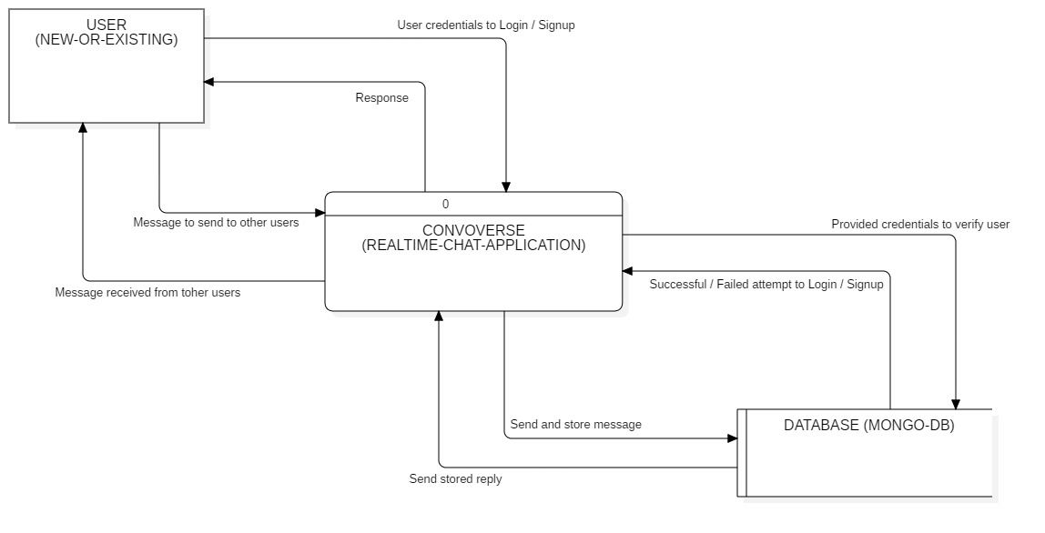

**Level – 1 Data Flow Diagram of the project**

1. Existing users log in through the Login component, which validates credentials against the User Database.
2. A backend response to successful validation results in user access, while unsuccessful attempts trigger an error popup.
3. New users access the Signup component to fill in required details for account creation.
4. The Signup component validates user credentials against the user schema.
5. Backend response leads to either successful account creation or displays an error message for failed validation.
6. After a successful account creation, users are seamlessly navigated to the Login component for login access.
7. Upon successful login, the backend fetches the channel database.
8. The user is presented with a comprehensive list of existing channels.
9. Users can create new channels from a designated section.
10. Users select a specific chat from the channel list, redirecting them to the Conversation component.
11. The Conversation component dynamically retrieves all existing messages from the channel database.
12. Users can send new messages and engage in conversations using the send message functionality.
13. Users can finally log out by clicking on the logout button.

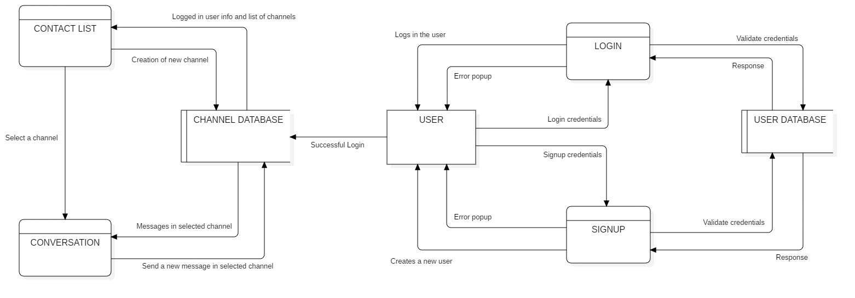

**Use Case Diagram of the project**

1. **Actors:**
2. User: Represents a system user, categorized as either New or Existing.
3. User Database (External): Stores user information and interacts with Login and Signup components.
4. Channel Database (External): Stores contact information and messages, interacts with Contact Item, Contact List, Message, and Conversation components.
5. **Use Cases:**
6. Signup: Allows New Users to register and create their accounts.
7. Login: Enables Existing Users to authenticate and access the system.
8. Contact List: Displays a list of all contacts for a Logged In User.
9. Contact Item: Represents an individual contact within the Contact List. Clicking a Contact Item opens the Conversation component.
10. Conversation: Shows the communication history with a specific contact.
11. Message: Represents individual messages within the Conversation.
12. **Relationships:**
13. Generalization: User is generalized into New User and Existing User.
14. Extension: Contact Item is an extension of Contact List, meaning it can be empty or contain Contact Items.
15. Extension: Message is an extension of Conversation, meaning it can be empty or contain Messages.
16. Include: To view Contact List or Conversation, User must be Logged In.
17. Include: Login includes Signup functionality, meaning users must be signed up to log in.
18. Include: User can only logout if Logged In.
19. Include: Logged In Users can create new contacts and search for other users.
20. Association: User Database interacts with Login and Signup components.
21. Association: Channel Database interacts with Contact Item, Contact List, Message, and Conversation components.

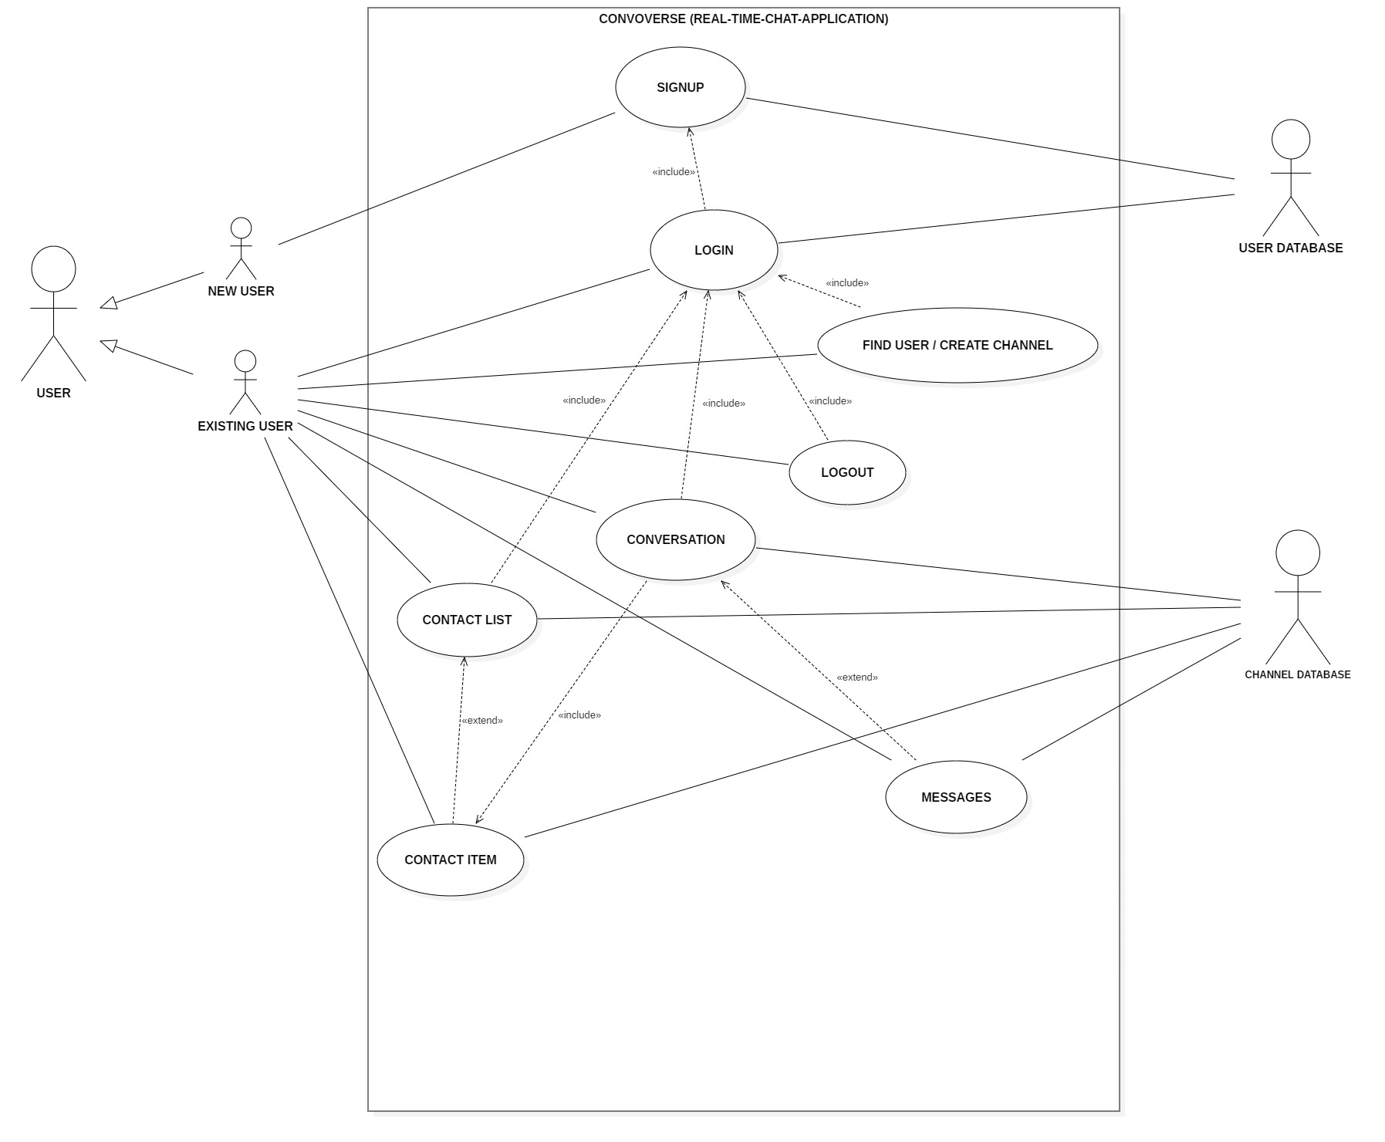

**Entity relationship Diagram for the Database structure**

1. The major objective of our chatting application called "Convoverse" was to create users first and then to create channels to send messages between users.
2. Each channel mainly has an attribute called "_id" that is unique for each channel, and an attribute called "addedOn" for storing the time when the was channel created.
3. Each channel also has an array of users called "channelUsers" which only consists of 2 users, the sender and receiver.
4. Each of these users has attributes as "_id" that is unique, "name" for storing the user's name, "phoneNumber" for storing the user's phone number, "profilePicURL" for storing the link to user's profile pic, "password" for storing the user's password and "addedOn" for storing the time when the user was created.
5. Each channel also has an array called "messages" which contains all the messages in the channel whether it is send by sender or reciever.
6. There can be unlimited number of messages, and each message has attributes as "_id" that is unique, "messageText" that contains the actual message being sent, "addedOn" for storing the time when the message was sent.
7. Each channel also has 2 additional attributes, first being "channelID" which tells which channel this message is a part of, and "senderID" which tells out of the 2 users present in the channel, who sent this message.

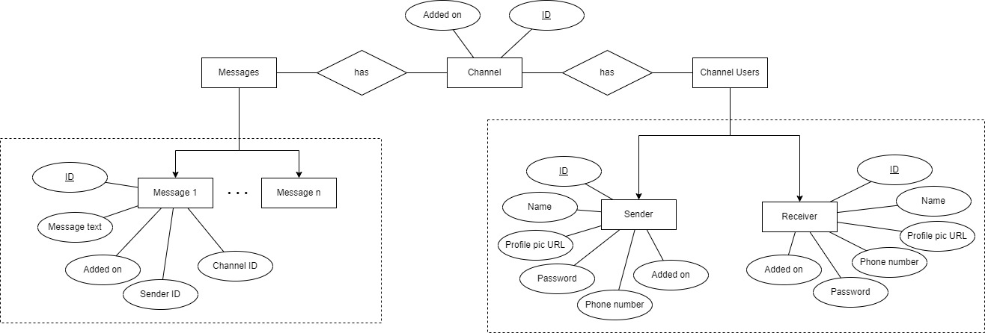

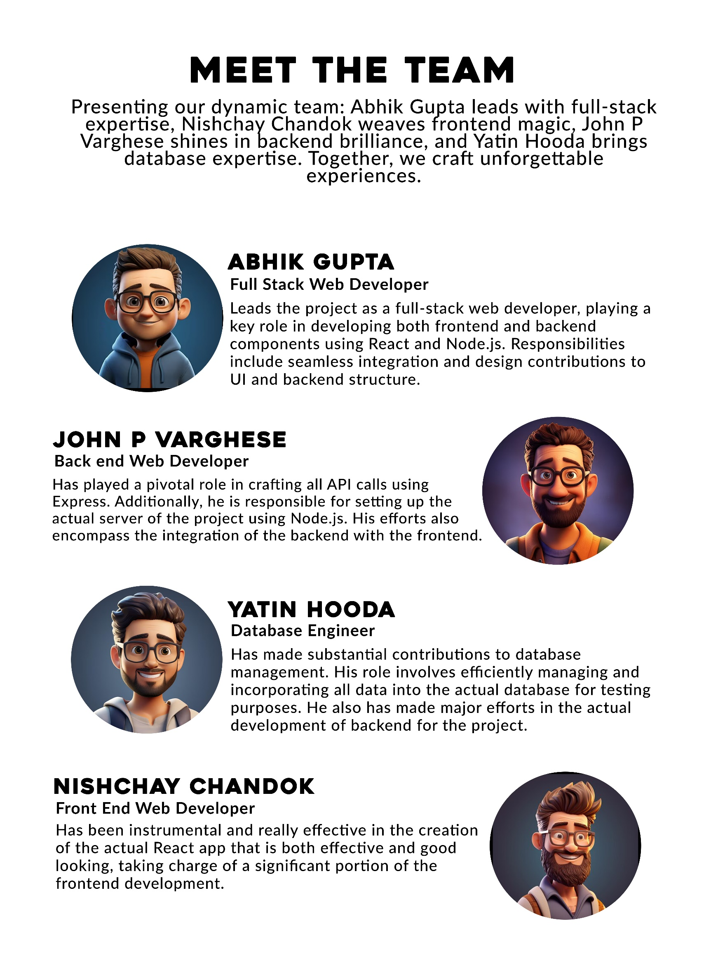

**CODING AND IMPLEMENTATION**

**CONVOVERSE PROJECT**

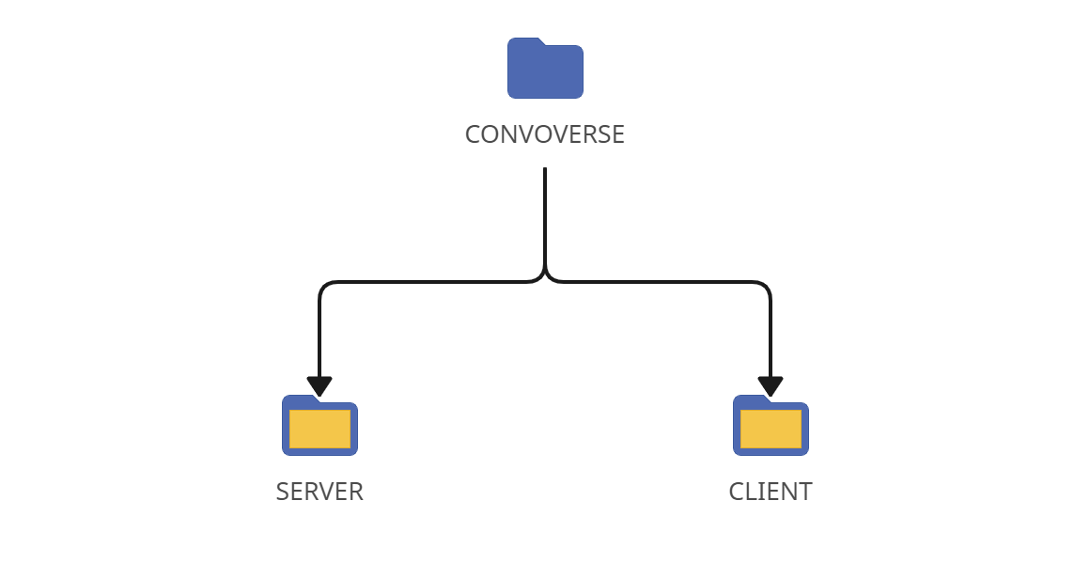

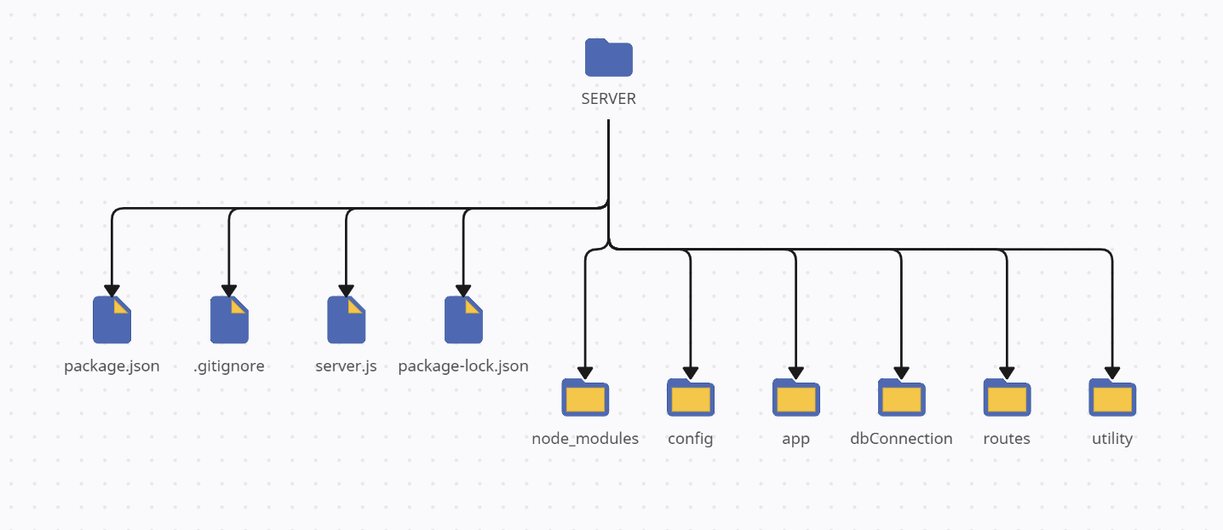**SERVER**

**package.json (server)**

{

"type": "module",

"name": "convoverse",

"version": "1.0.0",

"description": "A real time chat application for our minor project",

"main": "server.js",

"scripts": {

"start": "node server.js",

"test": "echo \"Error: no test specified\" && exit 1"

},

"author": "AbhikGupta",

"license": "ISC",

"dependencies": {

"babel": "^6.23.0",

"babel-cli": "^6.26.0",

"babel-preset-node8": "^1.2.0",

"body-parser": "^1.20.2",

"compression": "^1.7.4",

"cors": "^2.8.5",

"express": "^4.18.2",

"moment": "^2.29.4",

"moment-timezone": "^0.5.43",

"mongoose": "^7.6.7",

"yup": "^1.3.2"

},

"devDependencies": {

"@babel/core": "^7.23.2",

"@babel/node": "^7.22.19"

}

}

**.gitignore (server)**

./node_modules

**server.js (server)**

import APP from "express";

import connectDB from "./dbConnection/index.js";

import configureExpressApp from "./config/index.js";

import applyRoutes from "./routes/index.js";

// Creating a new instance of the Express application

const app = new APP();

// Configuring the Express application using the imported function

configureExpressApp(app);

// Defining the port on which the server will run

const PORT = 3005;

// Function to start the server

const startServer = () => {

Promise.all([connectDB()]).then(() => {

app.listen(PORT);

console.log(`-- Server started at port ${PORT} --`);

applyRoutes(app);

})

}

startServer();

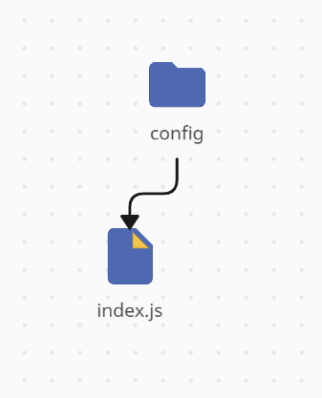

**index.js (config)**

import bodyParser from "body-parser";

import compression from "compression";

import cors from "cors";

const configureExpressApp = (app) => {

// Parse URL-encoded data and populate req.body

app.use(bodyParser.urlencoded({extended:true}));

// Parse JSON data and populate req.body

app.use(bodyParser.json());

// Enable response compression with compression level 9

app.use(compression(9));

// Enable Cross-Origin Resource Sharing (CORS)

app.use(cors());

}

export default configureExpressApp;

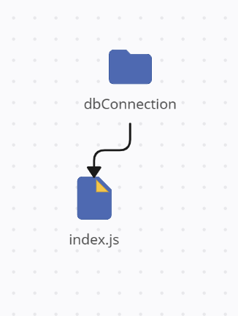

**index.js (dbConnection)**

import mongoose from "mongoose";

// MongoDB connection URL

const DB_CONNECTION_URL = 'mongodb://127.0.0.1:27017/convoverseDB';

// Function to connect to the MongoDB database

const connectDB = () => {

console.log(`-- Database is trying to connect on ${new Date()} --`);

const options = {

keepAlive: true,

autoReconnect: true,

poolSize: 10,

useNewUrlParser: true,

useUnifiedTopology: true,

}

return mongoose.connect(DB_CONNECTION_URL, options);

}

export default connectDB;

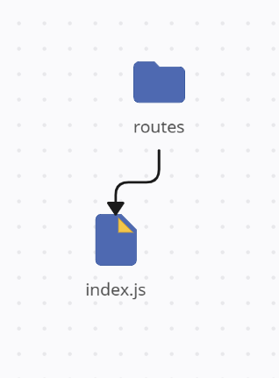

**index.js (routes)**

import * as Controller from "../app/controllers/index.js";

import * as Validation from "../utility/validations.js ";

const applyRoutes = (app) => {

// Default route to check if the API is running

app.get('/', (req, res) => res.json('API is running!'));

// Route to create a new user, with validation and controller handling

app.post('/user', Validation.validateCreateUser, Controller.createUser);

// Route for user login, with validation and controller handling

app.post('/login', Validation.validateLogin, Controller.loginUser);

// Route to create a new channel, with validation and controller handling

app.post('/channel', Validation.validateCreateChannel, Controller.createChannel);

// Route to get a list of channels, with validation and controller handling

app.get('/channel-list', Validation.validateGetChannels, Controller.getChannels);

// Route to search for a user, with validation and controller handling

app.get('/search-user', Validation.validateSearchUser, Controller.searchUser);

// Route to send a message, with validation and controller handling

app.post('/message', Validation.validateAddMessage, Controller.sendMessage);

}

export default applyRoutes;

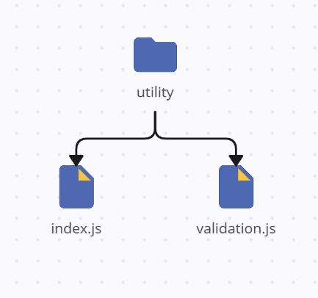

**index.js (utility)**

// Function to send a formatted success response

const sendResponse = (res, data, msg, success, code) => {

// Creating a response object with specified properties

const responseObj = {

responseData: data,

message: msg,

success: success,

responseCode: code

}

// Sending the response in JSON format

res.format({

json: () => {

res.send(responseObj);

}

})

}

// Function to send a formatted error response

const sendError = (res, data, msg) => {

// Calling the sendResponse function with default error values

sendResponse(res, data, msg || "Request failed!", false, 400);

}

export { sendResponse, sendError };

**validation.js (utility)**

import { sendError } from "./index.js";

import * as yup from "yup";

// Validation middleware for creating a user

export const validateCreateUser = async (req, res, next) => {

const schema = yup.object().shape({

phoneNumber: yup.number().required(),

name: yup.string().min(3, 'Name must be at least 3 characters!').required(),

password: yup.string().min(8, 'Password must be at least 8 characters!').required(),

profilePic: yup.string().url()

});

await validate(schema, req.body, res, next);

};

// Validation middleware for user login

export const validateLogin = async (req, res, next) => {

const schema = yup.object().shape({

phoneNumber: yup.number().required(),

password: yup.string().required()

});

await validate(schema, req.body, res, next);

};

// Validation middleware for creating a channel

export const validateCreateChannel = async (req, res, next) => {

const schema = yup.object().shape({

channelUsers: yup.array().of(

yup.object().shape({

_id: yup.string().required(),

name: yup.string().required(),

profilePic: yup.string()

})

).length(2).required()

});

await validate(schema, req.body, res, next);

};

// Validation middleware for getting channels

export const validateGetChannels = async (req, res, next) => {

const schema = yup.object().shape({

userId: yup.string().required()

});

await validate(schema, req.query, res, next);

};

// Validation middleware for searching for a user

export const validateSearchUser = async (req, res, next) => {

const schema = yup.object().shape({

phone: yup.number().required()

});

await validate(schema, req.query, res, next);

};

// Validation middleware for adding a message to a channel

export const validateAddMessage = async (req, res, next) => {

const schema = yup.object().shape({

channelId: yup.string().required(),

messages: yup.object().shape({

senderID: yup.string().required(),

message: yup.string().required()

})

});

await validate(schema, req.body, res, next);

};

// Common validation function used by other validation middlewares

const validate = async (schema, reqData, res, next) => {

try {

await schema.validate(reqData, { abortEarly: false });

next();

}

catch (e) {

const errors = e.inner.map(({ path, message, value }) => ({

path,

message,

value

}));

sendError(res, errors, "Invalid request!");

}

};

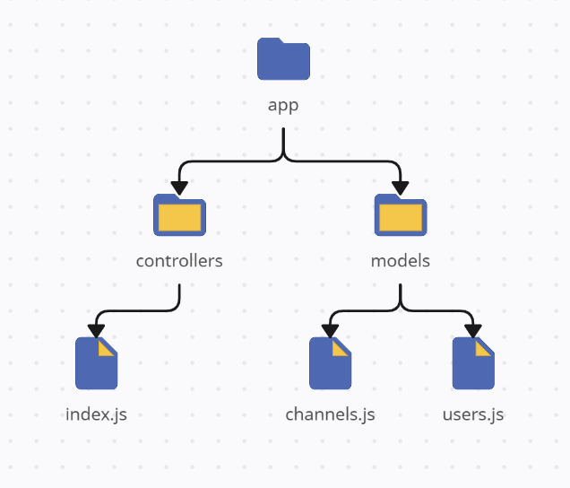

**index.js (controllers)**

import UserModel from "../models/users.js";

import ChannelModel from "../models/channels.js";

import { sendResponse, sendError } from "../../utility/index.js";

// Creating a new user

export const createUser = async (req, res) => {

const userObj = new UserModel(req.body);

await userObj.saveData();

sendResponse(res, userObj, "User created successfully!", true, 200);

};

// Logging in a user

export const loginUser = async (req, res) => {

const requestData = req.body;

const isUserExist = await UserModel.findOneData({

phoneNumber: requestData.phoneNumber,

password: requestData.password

});

// delete isUserExist.password;

if (!isUserExist) {

return sendError(res, {}, "User not found with those credentials!");

}

sendResponse(res, isUserExist, "User logged in successfully!", true, 200);

};

// Creating a new channel

export const createChannel = async (req, res) => {

const channelObj = new ChannelModel(req.body);

await channelObj.saveData();

sendResponse(res, channelObj, "Channel created successfully!", true, 200);

};

// Getting a list of channels for a user

export const getChannels = async (req, res) => {

const requestData = req.query;

const channelList = await ChannelModel.findData({

"channelUsers._id": requestData.userId

});

sendResponse(res, channelList, "Channel list fetched successfully!", true, 200);

};

// Searching for a user by phone number

export const searchUser = async (req, res) => {

const requestData = req.query;

const isUserExist = await UserModel.findOneData({

phoneNumber: requestData.phone

});

if (!isUserExist) {

return sendError(res, {}, "No user found!");

}

sendResponse(res, isUserExist, "User found successfully!", true, 200);

};

// Sending a message to a channel

export const sendMessage = async (req, res) => {

const requestData = req.body;

await ChannelModel.findOneAndUpdateData(

{ _id: requestData.channelId },

{ $push: { messages: requestData.messages } }

);

sendResponse(res, {}, "Message sent successfully!", true, 200);

};

**channels.js (models)**

import mongoose from "mongoose";

// Defining the schema for the 'channels' collection

const channelSchema = new mongoose.Schema({

// Array of channel users with their information

channelUsers: [

{

_id: { type: String, default: "" },

name: { type: String, default: "" },

profilePic: { type: String, default: "" }

}

],

// Array of messages in the channel

messages: [

{

senderID: { type: String, default: "" },

message: { type: String, default: "" },

addedOn: { type: Date, default: Date.now() }

}

],

// Timestamp indicating when the channel was added

addedOn: { type: Date, default: Date.now() }

});

// Defining instance methods for the channel schema

channelSchema.method({

// Method to save channel data to the database

saveData: async function() {

return this.save()

}

})

// Defining static methods for the channel schema

channelSchema.static({

// Method to find multiple channels based on a query object

findData: function(findObj) {

return this.find(findObj)

},

// Method to find a single channel based on a query object

findOneData: function(findObj) {

return this.findOne(findObj)

},

// Method to find and update a channel based on query and update objects

findOneAndUpdateData: function(findObj, updateObj) {

return this.findOneAndUpdate(findObj, updateObj, {

upsert: true,

new: true,

setDefaultsOnInsert: true

})

}

})

export default mongoose.model('channelSchema', channelSchema);

**users.js (models)**

import mongoose from "mongoose";

// Defining the schema for the 'users' collection

const userSchema = new mongoose.Schema({

name: { type: String, default: "" },

phoneNumber: { type: Number, default: "" },

password: { type: String, default: "" },

profilePic: { type: String, default: "" },

addedOn: { type: Date, default: Date.now() }

});

// Defining instance methods for the user schema

userSchema.method({

// Method to save user data to the database

saveData: async function() {

return this.save()

}

})

// Defining static methods for the user schema

userSchema.static({

// Method to find multiple users based on a query object

findData: function(findObj) {

return this.find(findObj)

},

// Method to find a single user based on a query object

findOneData: function(findObj) {

return this.findOne(findObj)

},

// Method to find and update a user based on query and update objects

findOneAndUpdateData: function(findObj, updateObj) {

return this.findOneAndUpdate(findObj, updateObj, {

upsert: true,

new: true,

setDefaultsOnInsert: true

})

}

})

export default mongoose.model('úserSchema', userSchema);

**CLIENT**

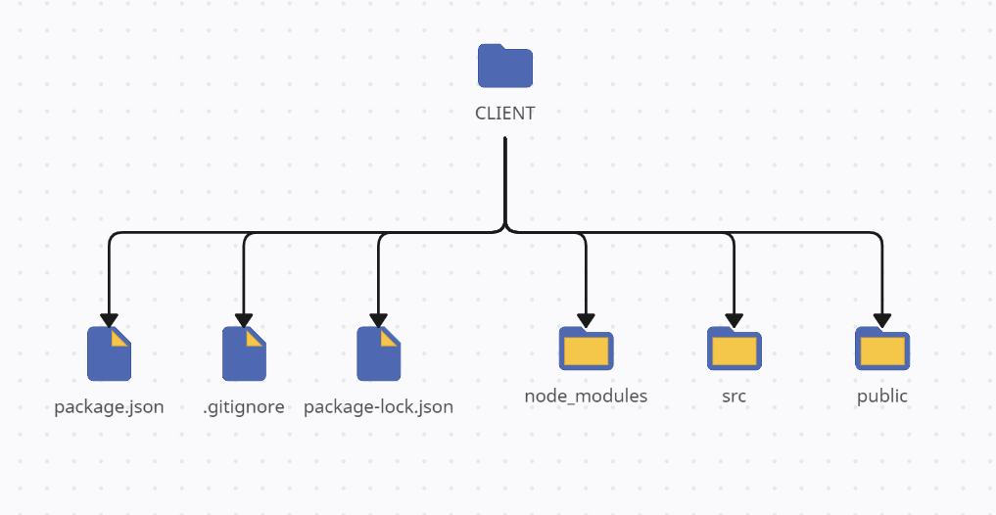

**package.json (client)**

{

"name": "whatsapp-clone",

"version": "0.1.0",

"private": true,

"dependencies": {

"@leecheuk/react-google-login": "^5.4.1",

"@testing-library/jest-dom": "^5.17.0",

"@testing-library/react": "^13.4.0",

"@testing-library/user-event": "^13.5.0",

"emoji-picker-react": "^4.5.2",

"react": "^18.2.0",

"react-dom": "^18.2.0",

"react-icons": "^4.11.0",

"react-router-dom": "^6.20.0",

"react-scripts": "5.0.1",

"react-toastify": "^9.1.3",

"styled-components": "^6.0.8",

"web-vitals": "^2.1.4"

},

"scripts": {

"start": "react-scripts start",

"build": "react-scripts build",

"test": "react-scripts test",

"eject": "react-scripts eject"

},

"eslintConfig": {

"extends": [

"react-app",

"react-app/jest"

]

},

"browserslist": {

"production": [

">0.2%",

"not dead",

"not op_mini all"

],

"development": [

"last 1 chrome version",

"last 1 firefox version",

"last 1 safari version"

]

}

}

**.gitignore (client)**

/node_modules

/.pnp

.pnp.js

/coverage

/build

.DS_Store

.env.local

.env.development.local

.env.test.local

.env.production.local

npm-debug.log*

yarn-debug.log*

yarn-error.log*

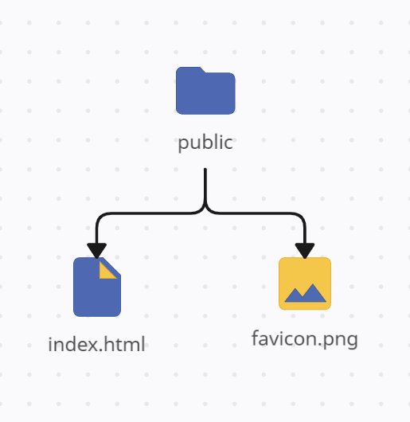

**index.html (public)**

<!DOCTYPE html>

<html lang="en">

<head>

<meta charset="utf-8" />

<link rel="icon" href="favicon.png" />

<meta name="viewport" content="width=device-width, initial-scale=1" />

<meta name="theme-color" content="#000000" />

<meta name="description" content="Convoverse is a cutting-edge real-time chat web application designed to redefine the way people connect and communicate online. " />

<title>CONVOVERSE - Send messages quick and securely!</title>

</head>

<body>

<noscript>You need to enable JavaScript to run this app.</noscript>

<div id="root"></div>

</body>

</html>

**favicon.png (public)**



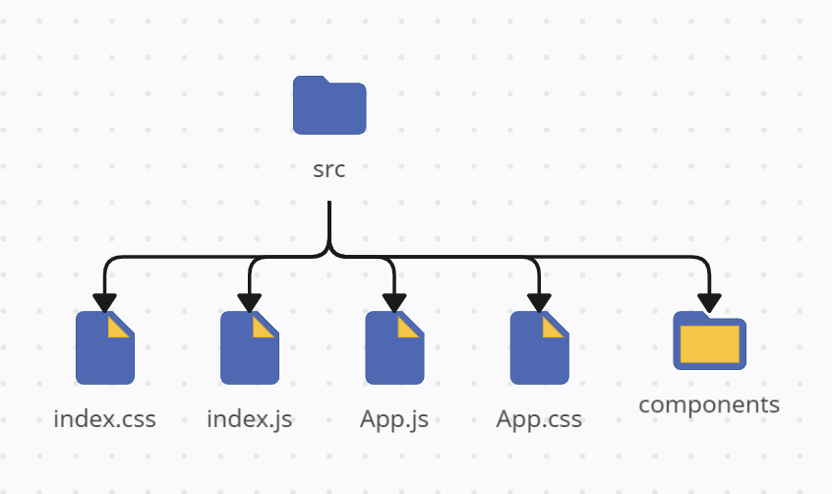

**index.js (src)**

import React from 'react';

import ReactDOM from 'react-dom/client';

import './index.css';

import App from './App';

import { BrowserRouter } from 'react-router-dom';

// Creating a React root and rendering the App component within it

const root = ReactDOM.createRoot(document.getElementById('root'));

root.render(

<React.StrictMode>

{/* Providing BrowserRouter to enable routing */}

<BrowserRouter>

{/* Rendering the main App component */}

<App />

</BrowserRouter>

</React.StrictMode>

);

**index.css (src)**

@import url('https://fonts.googleapis.com/css2?family=Noto+Sans:wght@100;200;300;400;500;600;700;800;900&display=swap');

* {

margin: 0;

padding: 0;

box-sizing: border-box;

font-family: 'Noto Sans', sans-serif;

}

html,

body {

height: 100%;

width: 100%;

}

**app.js (src)**

import React, { useState } from 'react';

import './App.css';

import { ToastContainer } from 'react-toastify';

import 'react-toastify/dist/ReactToastify.css';

import styled from 'styled-components';

import ContactList from './components/ContactList';

import Conversation from './components/Conversation';

import ChatSectionPlaceholder from './components/ChatSectionPlaceholder';

import Login from './components/Login';

import Signup from './components/Signup';

import { Route, Routes } from 'react-router-dom';

// Main App component

const App = () => {

// State to manage the display of placeholder and selected chat

const [ chatPlaceHolder, setChatPlaceHolder ] = useState(true);

const [ selectedChat, setSelectedChat ] = useState();

return (

<>

<Routes>

{/* Route for the login page */}

<Route path='/' element={<Login />} />

{/* Route for the signup page */}

<Route path='/signup' element={<Signup />} />

{/* Route for the home page */}

<Route path='/home' element={

<div className='app'>

{/* ContactList component */}

<ContactList setChatPlaceHolder={setChatPlaceHolder} setSelectedChat={setSelectedChat} />

{/* Conditional rendering based on 'chatPlaceHolder' state */}

{chatPlaceHolder ? (<ChatSectionPlaceholder />) : (<Conversation selectedChat={selectedChat} />)}

</div>

} />

</Routes>

<ToastContainer />

</>

)

}

export default App;

**app.css (src)**

.app {

display: flex;

flex-direction: row;

height: 100vh;

width: 100vw;

background-color: #f8f9fb;

}

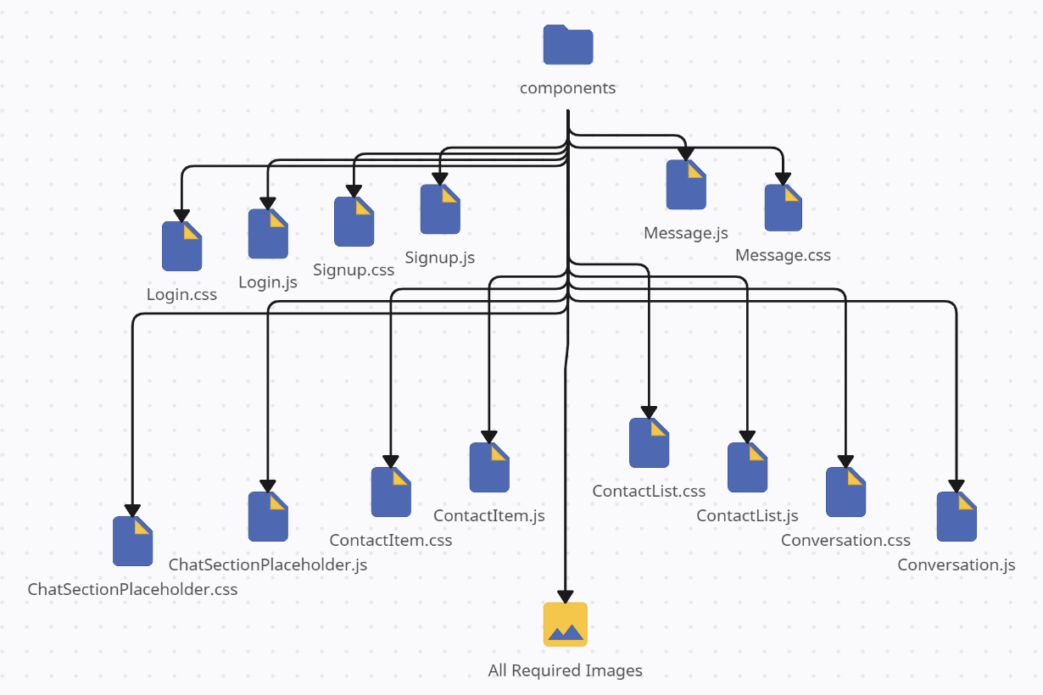

**ChatSectionPlaceholder.js (components)**

import React from 'react';

import './ChatSectionPlaceholder.css';

import placeholderImage from './ChatSectionPlaceholderImage.png';

// Functional component for displaying a placeholder in the chat section

const ChatSectionPlaceholder = () => {

return (

<div className='placeholderContainer'>

<div className="imageDiv">

<img src={placeholderImage} alt="Placeholder" />

</div>

<h1>Welcome to Convoverse!</h1>

<p>Whatsapp connects to your phone to sync messages<br></br>and provide you a seamless experience</p>

</div>

)

}

export default ChatSectionPlaceholder;

**ChatSectionPlaceholder.css (components)**

.placeholderContainer {

display: flex;

flex-direction: column;

align-items: center;

justify-content: center;

height: 100%;

width: 70%;

background-color: rgb(255, 252, 252);

}

.imageDiv {

padding: 1vmax;

border-radius: 50%;

display: flex;

align-items: center;

justify-content: center;

}

.imageDiv > img {

width: 12vmax;

transition: 0.5s;

}

.imageDiv > img:hover {

cursor: grab;

transform: scale(1.1);

}

.placeholderContainer > h1 {

font-size: 1.6vmax;

font-weight: 600;

color: #00000088;

}

.placeholderContainer > p {

font-size: 0.8vmax;

font-weight: 400;

color: #00000088;

text-align: center;

}

**ContactItem.js (components)**

import React, { useEffect, useState } from 'react';

import './ContactItem.css';

import { FaCheckCircle } from "react-icons/fa";

import { FaEnvelope } from "react-icons/fa";

// Functional component representing a contact item in the chat list

const ContactItem = (props) => {

// Destructuring props to extract relevant data and functions

const { userInfo, setChatPlaceHolder, setSelectedChat } = props;

// State to manage display data for the user

const [userDisplayData, setUserDisplayData] = useState({ userDisplayPic: '', userDisplayName: '' });

// States for the last message and its sender indicator

const [lastMessage, setLastMessage] = useState('');

const [lastMessageSign, setLastMessageSign] = useState();

// Function to fetch and set user display data based on the channel users

function fetchContactData() {

if (localStorage.getItem('convoverseUserLoginId') === userInfo.channelUsers[0]._id) {

setUserDisplayData({ userDisplayPic: userInfo.channelUsers[1].profilePic, userDisplayName: userInfo.channelUsers[1].name })

}

else {

setUserDisplayData({ userDisplayPic: userInfo.channelUsers[0].profilePic, userDisplayName: userInfo.channelUsers[0].name })

}

}

// Function to fetch and set the last message and its sender indicator

function fetchLastMessage() {

if (userInfo.messages.length > 0) {

const length = userInfo.messages.length;

const lastMsg = userInfo.messages[length - 1];

if (lastMsg.senderID === localStorage.getItem('convoverseUserLoginId')) {

setLastMessageSign(0);

}

else {

setLastMessageSign(1);

}

const lastMsgText = lastMsg.message.slice(0, 40);

setLastMessage(lastMsgText);

}

}

// useEffect to fetch user display data and the initial last message on component mount

useEffect(() => {

fetchContactData();

fetchLastMessage();

// eslint-disable-next-line react-hooks/exhaustive-deps

}, []);

// useEffect to update the last message when there's a change in userInfo.messages

useEffect(() => {

fetchLastMessage();

// eslint-disable-next-line react-hooks/exhaustive-deps

}, [userInfo.messages]);

return (

<div className='contactItemContainer' onClick={() => {

setChatPlaceHolder(false);

setSelectedChat(userInfo);

}}>

<div className="leftSection">

<div className="chatDP">

<img src={userDisplayData.userDisplayPic} alt="DP" />

</div>

<div className="chatContent">

<h1 className='contactName'>{userDisplayData.userDisplayName}</h1>

<p className='lastText'>{lastMessage}</p>

</div>

</div>

<div className="rightSection">

{/* Conditional rendering based on the lastMessageSign */}

{lastMessageSign === 0 ? <p className='sentSign'><FaCheckCircle /></p> : <p className='recievedSign'><FaEnvelope /></p>}

</div>

</div>

)

}

export default ContactItem;

**ContactItem.css (components)**

.contactItemContainer {

height: 5vmax;

border-bottom: 2px solid #b3b3b3;

display: flex;

flex-direction: row;

align-items: center;

background-color: #ffffffdc;

padding: 0px 0.4vmax;

transition: 0.3s;

}

.contactItemContainer:hover {

background-color: #00977e;

cursor: grab;

}

.contactItemContainer:active {

cursor: grabbing;

}

.contactItemContainer:hover .chatContent > h1 {

color: #fff;

}

.contactItemContainer:hover .chatContent > p {

color: #ffffffcc;

}

.contactItemContainer:hover .rightSection > p {

color: #ffffffcc;

}

.leftSection {

width: 100%;

height: 100%;

display: flex;

flex-direction: row;

flex: 1;

}

.chatDP {

width: 20%;

height: 100%;

display: flex;

align-items: center;

justify-content: center;

}

.chatDP > img {

width: 75%;

height: 75%;

object-fit: cover;

object-position: center;

border-radius: 50%;

}

.chatContent {

width: 75%;

display: flex;

flex-direction: column;

justify-content: center;

gap: 0px;

padding-left: 0.3vmax;

}

.chatContent > h1 {

font-size: 1vmax;

transition: 0.3s;

color: #000;

font-weight: 800;

}

.chatContent > p {

font-size: 0.8vmax;

transition: 0.3s;

color: #000;

font-weight: 400;

}

.rightSection {

height: 100%;

width: 15%;

display: flex;

align-items: center;

justify-content: center;

font-size: 0.8vmax;

}

.rightSection > p {

font-size: 1vmax;

font-weight: 500;

transition: 0.3s;

}

.sentSign {

color: #00000062;

}

.recievedSign {

color: #00b395;

}

**ContactList.js (components)**

import React, { useEffect, useState } from 'react';

import './ContactList.css';

import { ImSearch } from "react-icons/im";

import ContactItem from './ContactItem';

import { useNavigate } from 'react-router-dom';

import { toast } from 'react-toastify';

// Functional component representing the list of contacts in the chat application

const ContactList = (props) => {

// Destructuring props to extract relevant data and functions

const { setChatPlaceHolder, setSelectedChat } = props;

// States to manage user information, search text, and navigation

const [userInfo, setUserInfo] = useState([]);

const [searchText, setSearchText] = useState('');

const navigate = useNavigate();

// Function to logout the user and navigate to the login page

function logoutUser() {

localStorage.removeItem('convoverseUserLoginId');

localStorage.removeItem('convoverseUserLoginName');

localStorage.removeItem('convoverseUserLoginProfilePic');

setChatPlaceHolder(true);

// Toast notification for successful user logout

toast.success('User logged out successfully!', {

position: "bottom-right",

autoClose: 2000,

hideProgressBar: false,

closeOnClick: true,

pauseOnHover: true,

draggable: true,

progress: undefined,

theme: "colored",

});

// Navigating to the login page

navigate('/');

}

// Function to fetch user channels

async function fetchChannels() {

const loggedInUserId = localStorage.getItem('convoverseUserLoginId');

const response = await fetch(`http://localhost:3005/channel-list?userId=${loggedInUserId}`, {

method: 'GET',

headers: {

'Content-Type': 'application/json'

}

});

const jsonResponse = await response.json();

setUserInfo(jsonResponse.responseData);

}

// Function to refresh user channels

async function refreshChannels() {

const loggedInUserId = localStorage.getItem('convoverseUserLoginId');

const response = await fetch(`http://localhost:3005/channel-list?userId=${loggedInUserId}`, {

method: 'GET',

headers: {

'Content-Type': 'application/json'

}

});

const jsonResponse = await response.json();

setUserInfo(jsonResponse.responseData);

setSearchText('');

}

// Event handler for text input change

function onChange(e) {

setSearchText(e.target.value);

}

// Function to search for a user and initiate a chat

async function searchUser() {

const searchResponse = await fetch(`http://localhost:3005/search-user?phone=${searchText}`, {

method: 'GET',

headers: {

'Content-Type': 'application/json'

}

});

const searchResponseJSON = await searchResponse.json();

if (searchResponseJSON.responseData && searchResponseJSON.responseData._id) {

const searchResult = searchResponseJSON.responseData;

// Fetching user channels

const getChannelResponse = await fetch(`http://localhost:3005/channel-list?userId=${localStorage.getItem('convoverseUserLoginId')}`, {

method: 'GET',

headers: {

'Content-Type': 'application/json'

}

});

const getChannelResponseJSON = await getChannelResponse.json();

// Checking if a channel already exists with the searched user

const existingChannel = getChannelResponseJSON.responseData.find(channel =>

channel.channelUsers.some(user => user._id === searchResult._id)

);

// Creating a new channel if it doesn't exist

if (!existingChannel) {

const channelResponse = await fetch('http://localhost:3005/channel', {

method: 'POST',

headers: {

'Content-Type': 'application/json'

},

body: JSON.stringify({

channelUsers: [

{

_id: localStorage.getItem('convoverseUserLoginId'),

name: localStorage.getItem('convoverseUserLoginName'),

profilePic: localStorage.getItem('convoverseUserLoginProfilePic')

},

{

_id: searchResult._id,

name: searchResult.name,

profilePic: searchResult.profilePic

}

]

})

});

const channelResponseJSON = await channelResponse.json();

if(channelResponseJSON){

// Toast notification for successful channel creation

toast.success('A new chat created successfully!', {

position: "bottom-right",

autoClose: 2000,

hideProgressBar: false,

closeOnClick: true,

pauseOnHover: true,

draggable: true,

progress: undefined,

theme: "colored",

});

}

else{

// Toast notification for unsuccessful channel creation

toast.error('Something went wrong!', {

position: "bottom-right",

autoClose: 2000,

hideProgressBar: false,

closeOnClick: true,

pauseOnHover: true,

draggable: true,

progress: undefined,

theme: "colored",

});

}

}

else {

// Toast notification if a channel already exists with the user

toast.info('You already have a chat with this user!', {

position: "bottom-right",

autoClose: 2000,

hideProgressBar: false,

closeOnClick: true,

pauseOnHover: true,

draggable: true,

progress: undefined,

theme: "colored",

});

}

// Refreshing user channels after the operation

refreshChannels();

}

else {

// Toast notification if the user is not found

toast.error('Sorry could not find the user!', {

position: "bottom-right",

autoClose: 2000,

hideProgressBar: false,

closeOnClick: true,

pauseOnHover: true,

draggable: true,

progress: undefined,

theme: "colored",

});

}

}

// Event handler for the "Enter" key press

function onEnterPress(e) {

if (e.key === "Enter") {

searchUser();

}

}

// useEffect to fetch user channels on component mount

useEffect(() => {

fetchChannels();

}, []);

return (

<div className='contactListContainer'>

<div className='contactListHeader'>

<div className="profileInfo">

<div className="profilePic">

<img src={localStorage.getItem('convoverseUserLoginProfilePic')} alt='Profile' />

</div>

<div className="profileName">

<p>{localStorage.getItem('convoverseUserLoginName')}</p>

</div>

</div>

<div className="logoutDiv">

<button className="logoutButton" onClick={logoutUser}>Logout</button>

</div>

</div>

<div className="searchDiv">

<div className="searchLogo">

<ImSearch className='ImSearch' onClick={searchUser} />

</div>

<div className="searchBox">

<input type="text" placeholder='Start a new chat by phone number' value={searchText} onChange={onChange} onKeyDown={onEnterPress} />

</div>

</div>

<div className="listOfContacts">

{/* Mapping through user channels and rendering ContactItem component for each */}

{userInfo.map((item) =>

<ContactItem key={item._id} userInfo={item} setChatPlaceHolder={setChatPlaceHolder} setSelectedChat={setSelectedChat} />

)}

</div>

</div>

)

}

export default ContactList;

**ContactList.css (components)**

.contactListContainer {

display: flex;

flex-direction: column;

height: 100%;

background-color: #004e41;

width: 30%;

}

.listOfContacts {

overflow: scroll;

overflow-x: hidden;

}

.listOfContacts::-webkit-scrollbar {

width: 0;

}

.contactListHeader {

display: flex;

flex-direction: row;

align-items: center;

justify-content: space-between;

background: linear-gradient(to bottom right, #022423, #004136, #00725f, #00977e);

color: #fff;

padding: 0.5vmax;

height: 8%;

}

.profileInfo {

display: flex;

flex-direction: row;

align-items: center;

gap: 0.5vmax;

height: 100%;

width: 80%;

margin-top: 1vmax;

padding-left: 0.3vmax;

}

.profilePic {

height: 3vmax;

width: 3vmax;

}

.profilePic > img {

width: 100%;

height: 100%;

object-fit: cover;

object-position: center;

border-radius: 50%;

}

.profileName > p {

font-weight: 800;

font-size: 1.3vmax;

}

.logoutDiv {

height: 100%;

width: 20%;

display: flex;

align-items: center;

justify-content: flex-end;

margin-top: 1vmax;

}

.logoutButton {

border: none;

outline: none;

padding: 0.4vmax;

background-color: #ffffff9d;

color: #006454;

font-size: 1vmax;

font-weight: 700;

border-radius: 10px;

transition: 0.3s;

}

.logoutButton:hover {

cursor: grab;

background-color: rgba(255, 255, 255, 0.76);

}

.logoutButton:active {

cursor: grabbing;

}

.searchDiv {

height: 8%;

display: flex;

flex-direction: row;

align-items: center;

justify-content: center;

background: linear-gradient(to top right, #022423, #004136, #00725f, #00977e);

padding: 0.5vmax;

}

.searchLogo {

width: 10%;

height: 75%;

display: flex;

align-items: center;

justify-content: center;

background-color: #ffffffdc;

border-top-left-radius: 25px;

border-bottom-left-radius: 25px;

}

.searchBox {

width: 90%;

height: 75%;

display: flex;

align-items: center;

justify-content: flex-start;

border-top-right-radius: 25px;

border-bottom-right-radius: 25px;

overflow: hidden;

}

.searchBox > input {

background-color: #ffffffdc;

height: 100%;

width: 100%;

border: none;

outline: none;

font-size: 0.8vmax;

}

.ImSearch {

font-size: 1.1vmax;

}

.listOfContacts {

height: 84%;

background: linear-gradient(to bottom right, #022423, #004136, #00725f, #00977e);

}

**Conversation.js (components)**

import React, { useEffect, useState } from 'react';

import './Conversation.css';

import { HiOutlineEmojiHappy } from "react-icons/hi";

import { AiOutlineSend } from "react-icons/ai";

import Message from './Message';

import EmojiPicker from 'emoji-picker-react';

import ConversationWallpaper from './ConversationWallpaper.jpg';

// Functional component representing a conversation in the chat application

const Conversation = (props) => {

// Destructuring props to extract relevant data

const { selectedChat } = props;

// States to manage message input, emoji picker visibility, message list, and active user data

const [messageText, setMessageText] = useState('');

const [pickerVisible, setPickerVisible] = useState(false);

const [messageList, setMessageList] = useState([]);

const [activeUserData, setActiveUserData] = useState({ activeUserName: '', activeUserProfilePic: '' });

// Event handler for handling changes in the message input

function handleChange(e) {

setMessageText(e.target.value);

}

// Event handler for emoji click in the emoji picker

function onEmojiClick(emojiObject) {

let emoji = emojiObject.emoji;

console.log(messageText);

console.log(emoji);

setMessageText(messageText => messageText + emoji);

// setPickerVisible(false);

}

// Function to toggle visibility of the emoji picker

function toggleEmojiPicker() {

setPickerVisible(!pickerVisible);

}

// Function to refresh messages in the current conversation

async function refreshMessages() {

const loggedInUserID = localStorage.getItem('convoverseUserLoginId');

const newResponse = await fetch(`http://localhost:3005/channel-list?userId=${loggedInUserID}`, {

method: 'GET',

headers: {

'Content-Type': 'application/json'

}

});

const newResponseJSON = await newResponse.json();

const requiredChat = newResponseJSON.responseData.filter((item) => item._id === selectedChat._id);

setMessageList(requiredChat[0].messages);

}

// Function to send a message

async function sendMessage() {

if (messageText !== '') {

await fetch('http://localhost:3005/message', {

method: 'POST',

headers: {

'Content-Type': 'application/json'

},

body: JSON.stringify({

channelId: selectedChat._id, messages: {

senderID: localStorage.getItem('convoverseUserLoginId'),

message: messageText

}

})

});

setMessageText('');

setPickerVisible(false);

if (selectedChat.messages.length !== 0) {

refreshMessages();

}

}

}

// Event handler for the "Enter" key press

function onEnterPress(e) {

if (e.key === "Enter") {

sendMessage();

}

}

// Function to fetch active user data for the conversation

function fetchActiveUserData() {

if (localStorage.getItem('convoverseUserLoginId') === selectedChat.channelUsers[0]._id) {

setActiveUserData({ activeUserName: selectedChat.channelUsers[1].name, activeUserProfilePic: selectedChat.channelUsers[1].profilePic });

}

else {

setActiveUserData({ activeUserName: selectedChat.channelUsers[0].name, activeUserProfilePic: selectedChat.channelUsers[0].profilePic });

}

}

// Function to fetch all messages in the conversation

function fetchAllMessages() {

const allMessages = selectedChat.messages;

console.log(allMessages);

setMessageList(allMessages);

}

// useEffect to fetch active user data and all messages on component mount and when the selectedChat changes

useEffect(() => {

fetchActiveUserData();

fetchAllMessages();

// eslint-disable-next-line react-hooks/exhaustive-deps

}, [selectedChat]);

// useEffect to refresh messages when the messageList changes

useEffect(() => {

refreshMessages();

// eslint-disable-next-line react-hooks/exhaustive-deps

}, [messageList]);

// Styling for the conversation wallpaper

const conversationWallpaperStyling = {

backgroundImage: `url(${ConversationWallpaper})`,

backgroundPosition: 'center',

backgroundSize: 'cover',

backgroundRepeat: 'no-repeat',

backgroundAttachment: 'fixed'

}

return (

<div className='conversationContainer'>

<div className="conversationHeader">

<div className="chatPerson">

<div className="personDP">

<img src={activeUserData.activeUserProfilePic} alt="PERSON DP" />

</div>

<div className="personName">

<p>{activeUserData.activeUserName}</p>

</div>

</div>

</div>

<div className="chatSection" style={conversationWallpaperStyling}>

{/* Mapping through messages and rendering Message component for each */}

{messageList.map((msg) =>

<Message key={msg._id} messageContent={msg.message} senderIsMe={msg.senderID === localStorage.getItem('convoverseUserLoginId')} timestamp={msg.addedOn} />

)}

</div>

<div className="sendMessageDiv">

<div className="emojiLogo">

<div className='emojiContainer'>

{pickerVisible && <EmojiPicker height={500} width={400} onEmojiClick={onEmojiClick} />}

</div>

<HiOutlineEmojiHappy className='HiOutlineEmojiHappy' onClick={toggleEmojiPicker} />

</div>

<div className="messageInput">

<input type="text" placeholder="Type a message" onKeyDown={onEnterPress} value={messageText} onChange={handleChange} />

</div>

<div className="sendLogo">

<AiOutlineSend className='AiOutlineSend' onClick={sendMessage} />

</div>

</div>

</div>

)

}

export default Conversation;

**Conversation.css (components)**

.conversationContainer {

display: flex;

flex-direction: column;

height: 100%;

width: 70%;

background-color: #f8f9fb;

position: relative;

}

.conversationHeader {

background: linear-gradient(to bottom right, #022423, #004136, #00725f, #00977e);

height: 8%;

width: 100%;

display: flex;

align-items: center;

justify-content: space-between;

flex-direction: row;

padding: 0px 1vmax;

color: #fff;

}

.chatPerson {

display: flex;

align-items: center;

flex-direction: row;

height: 100%;

width: 100%;

gap: 0.8vmax;

}

.personDP {

display: flex;

align-items: center;

justify-content: center;

width: 3.5vmax;

height: 3.5vmax;

border: 2px solid #00BFA0;

border-radius: 50%;

}

.personDP > img {

height: 100%;

width: 100%;

object-fit: cover;

border-radius: 50%;

padding: 0.1vmax;

}

.personName > p {

font-size: 1.4vmax;

font-weight: 700;

}

.chatSection {

height: 84%;

width: 100%;

display: flex;

flex-direction: column;

gap: 0.6vmax;

padding: 1vmax;

overflow: scroll;

overflow-x: hidden;

}

.emojiContainer {

position: absolute;

bottom: 4.12vmax;

left: 1vmax;

}

.chatSection::-webkit-scrollbar {

width: 0;

}

.sendMessageDiv {

width: 100%;

height: 8%;

background: linear-gradient(to top right, #022423, #004136, #00725f, #00977e);

display: flex;

flex-direction: row;

align-items: center;

padding: 0px 1vmax;

}

.emojiLogo {

height: 60%;

width: 5%;

background-color: #ffffffbe;

display: flex;

align-items: center;

justify-content: center;

border-top-left-radius: 50px;

border-bottom-left-radius: 50px;

cursor: pointer;

}

.HiOutlineEmojiHappy {

font-size: 1.5vmax;

}

.messageInput {

height: 60%;

width: 90%;

}

.messageInput > input {

height: 100%;

width: 100%;

border: none;

outline: none;

font-size: 1vmax;

background-color: #ffffffbe;

}

.sendLogo {

height: 60%;

width: 5%;

background-color: #ffffffbe;

display: flex;

align-items: center;

justify-content: center;

border-top-right-radius: 50px;

border-bottom-right-radius: 50px;

cursor: pointer;

}

.AiOutlineSend {

font-size: 1.5vmax;

}

.startTalkingDiv {

width: 35%;

height: 20%;

background-color: #000000b6;

border-radius: 30px;

position: absolute;

top: 50%;

left: 50%;

transform: translate(-50%, -50%);

display: flex;

align-items: center;

justify-content: center;

color: #fff;

font-size: 1.2vmax;

box-shadow: 0px 0px 30px #000;

}

**Message.js (components)**

import React from 'react';

import './Message.css';

// Functional component representing a chat message

const Message = (props) => {

// Destructuring props to extract message content and sender information

const { messageContent, senderIsMe, timestamp } = props;

const tooltipContent = timestamp.slice(11,19) + " | " + timestamp.slice(0,10);

// Conditional rendering based on whether the message is sent by the user or received from others

if(senderIsMe){

return (

<div className='sentMessageDiv'>

<div className="sentMessage msg" title={tooltipContent}>

{messageContent}

</div>

</div>

)

}

else{

return (

<div className='receivedMessageDiv'>

<div className="receivedMessage msg" title={tooltipContent}>

{messageContent}

</div>

</div>

)

}

}

export default Message;

**Message.css (components)**

.sentMessageDiv {

display: flex;

justify-content: flex-end;

}

.receivedMessageDiv {

display: flex;

justify-content: flex-start;

}

.msg {

color: #000;

max-width: 60%;

padding: 0.5vmax;

font-size: 0.9vmax;

border-radius: 6px;

font-weight: 500;

transition: 0.3s;

}

.msg:hover {

cursor: grab;

transform: scale(1.02);

box-shadow: 0px 0px 40px #000;

}

.sentMessage {

/* background-color: #00d8b4; */

background-color: #00f3cb;

}

.receivedMessage {

background-color: #FFFFFF;

}

**Login.js (components)**

import React, { useState } from 'react';

import './Login.css';

import qrCode from './LoginQRcode.png';

import loginLogo from './LoginLogo.png';

import { Link, useNavigate } from 'react-router-dom';

import { toast } from 'react-toastify';

// Functional component representing the login page

const Login = () => {

// State to manage user credentials

const [credentials, setCredentials] = useState({ phoneNumber: '', password: '', profilePic: '' });

const navigate = useNavigate();

// Event handler for input changes

function onChange(e) {

setCredentials({ ...credentials, [e.target.name]: e.target.value });

}

// Async function to handle form submission

async function handleSubmit(e) {

e.preventDefault();

const response = await fetch('http://localhost:3005/login', {

method: 'POST',

headers: {

'Content-Type': 'application/json'

},

body: JSON.stringify({ phoneNumber: credentials.phoneNumber, password: credentials.password, profilePic: credentials.profilePic })

});

const jsonResponse = await response.json();

// Handling the response from the server

if (jsonResponse.success) {

localStorage.setItem('convoverseUserLoginId', jsonResponse.responseData._id);

localStorage.setItem('convoverseUserLoginName', jsonResponse.responseData.name);

localStorage.setItem('convoverseUserLoginProfilePic', jsonResponse.responseData.profilePic);

// Navigating to home page and setting fields back to empty

setCredentials({ phoneNumber: '', password: '', profilePic: '' });

navigate('/home');

// Displaying a success toast message

toast.success(jsonResponse.message, {

position: "bottom-right",

autoClose: 2000,

hideProgressBar: false,

closeOnClick: true,

pauseOnHover: true,

draggable: true,

progress: undefined,

theme: "colored",

});

}

else {

// Displaying an error toast message

toast.error(jsonResponse.message, {

position: "bottom-right",

autoClose: 2000,

hideProgressBar: false,

closeOnClick: true,

pauseOnHover: true,

draggable: true,

progress: undefined,

theme: "colored",

});

}

}

return (

<div className='loginPage'>

<div className="loginTop">

<h1>CONVOVERSE</h1>

<h3>Chat with ease!</h3>

</div>

<div className="loginBottom">

</div>

<div className="loginCard">

<div className="cardLeft">

<h1>LOG IN</h1>

<div className="line"></div>

<form onSubmit={handleSubmit}>

<label htmlFor="phoneNumber">Phone Number</label> <br />

<input type="text" name="phoneNumber" id="phoneNumber" value={credentials.phoneNumber} onChange={onChange} placeholder='Ex: 989162XXXX' minLength="10" maxLength="12" required /><br />

<label htmlFor="password">Password</label> <br />

<input type="password" name="password" id="password" value={credentials.password} onChange={onChange} placeholder='Enter your password' minLength="8" maxLength="32" required />

<button type='submit' className='loginButton'><img src={loginLogo} alt="Google logo" />Log in</button>

{/* Link to navigate to the signup page */}

<Link to='/signup' className='signupText'>Not a user? Sign up</Link>

</form>

</div>

<div className="cardRight">

<img src={qrCode} alt="QR code" />

</div>

</div>

</div>

)

}

export default Login;

**Login.css (components)**

.loginPage {

height: 100vh;

width: 100vw;

background-color: #000;

display: flex;

flex-direction: column;

position: relative;

}

.loginTop {

background: linear-gradient(to bottom right, #022423, #004136, #00725f, #00977e);

height: 40%;

width: 100%;

padding: 5vmax;

}

.loginTop > h1 {

color: #fff;

font-size: 1.6vmax;

}

.loginTop > h3 {

color: #fff;

font-size: 0.8vmax;

}

.loginBottom {

background-color: #141414;

height: 60%;

width: 100%;

}

.loginCard {

position: absolute;

top: 48%;

left: 50%;

transform: translate(-50%, -50%);

width: 40%;

height: 45%;

background-color: #fff;

border-radius: 15px;

box-shadow: 0px 0px 30px #0000006b;

display: flex;

overflow: hidden;

}

.cardLeft {

width: 50%;

height: 100%;

padding: 2vmax;

}

.cardLeft > h1 {

font-size: 2vmax;

font-weight: 700;

}

.line {

height: 1%;

width: 100%;

border-radius: 10px;

background-color: #00000094;

margin-bottom: 1vmax;

}

form {

height: 80%;

width: 100%;

}

.cardLeft > form > label {

font-size: 1.5vmax;

}

.cardLeft > form > input {

font-size: 1vmax;

background-color: rgba(231, 231, 231, 0.678);

width: 100%;

outline: none;

border: none;

padding: 0.5vmax;

margin-bottom: 0.5vmax;

}

.cardLeft > form > .loginButton {

height: 20%;

width: 50%;

border-radius: 50px;

border: none;

outline: none;

background-color: #fff;

color: #000;

display: flex;

align-items: center;

justify-content: center;

gap: 0.5vmax;

box-shadow: 0px 0px 10px #0000004d;

margin-top: 0.8vmax;

margin-bottom: 1vmax;

font-size: 1vmax;

font-weight: 700;

transition: 0.3s;

}

.cardLeft > form > .loginButton:hover {

cursor: grab;

box-shadow: 0px 0px 10px #000000c5;

}

.cardLeft > form > .loginButton:active {

cursor: grabbing;

}

.cardLeft > form > .loginButton > img {

height: 50%;

width: 20%;

object-fit: contain;

}

.signupText {

color: #00977e;

font-size: 1vmax;

font-weight: 600;

text-decoration: none;

transition: 0.3s;

}

.signupText:hover {

color: #006b59;

cursor: pointer;

}

.cardRight {

width: 50%;

height: 100%;

background-color: #fff;

}

.cardRight > img {

width: 100%;

height: 100%;

object-fit: contain;

}

**Signup.js (components)**

import React, { useState } from 'react';

import './Signup.css';

import qrCode from './LoginQRcode.png';

import signupLogo from './SignupLogo.png';

import { Link, useNavigate } from 'react-router-dom';

import { toast } from 'react-toastify';

// Functional component representing the signup page

const Signup = () => {

// State to manage user credentials

const [credentials, setCredentials] = useState({ phoneNumber: '', name: '', password: '', profilePic:'' });

const navigate = useNavigate();

// Event handler for input changes

function onChange(e) {

setCredentials({ ...credentials, [e.target.name]: e.target.value });

}

// Async function to handle form submission

async function handleSubmit(e) {

e.preventDefault();

const response = await fetch('http://localhost:3005/user', {

method: 'POST',

headers: {

'Content-Type': 'application/json'

},

body: JSON.stringify({ phoneNumber: credentials.phoneNumber, name: credentials.name, password: credentials.password, profilePic: credentials.profilePic })

});

const jsonResponse = await response.json();

setCredentials({ phoneNumber: '', name: '', password: '', profilePic:'' });

// Handling the response from the server

if (jsonResponse.success) {

// Displaying a success toast message and navigating to the login page

toast.success(jsonResponse.message, {

position: "bottom-right",

autoClose: 2000,

hideProgressBar: false,

closeOnClick: true,

pauseOnHover: true,

draggable: true,

progress: undefined,

theme: "colored",

});

// Navigating back to login page

navigate('/');

}

else {

// Displaying a warning toast message if there are validation errors

toast.warning(jsonResponse.responseData[0].message, {

position: "bottom-right",

autoClose: 2000,

hideProgressBar: false,

closeOnClick: true,

pauseOnHover: true,

draggable: true,

progress: undefined,

theme: "colored",

});

}

}

return (

<div className='signupPage'>

<div className="signupTop">

<h1>CONVOVERSE</h1>

<h3>Chat with ease!</h3>

</div>

<div className="signupBottom">

</div>

<div className="signupCard">

<div className="cardLeft">

<h1>SIGN UP</h1>

<div className="line"></div>

<form onSubmit={handleSubmit}>

<label htmlFor="phoneNumber">Phone Number</label> <br />

<input type="text" name="phoneNumber" id="phoneNumber" value={credentials.phoneNumber} onChange={onChange} placeholder='Ex: 989162XXXX' minLength="10" maxLength="12" required /><br />

<label htmlFor="name">Name</label> <br />

<input type="text" name="name" id="name" value={credentials.name} onChange={onChange} placeholder='Ex: George Smith' required /><br />

<label htmlFor="password">Password</label> <br />

<input type="password" name="password" id="password" value={credentials.password} onChange={onChange} placeholder='Must be 8 characters' required /><br />

<label htmlFor="profilePic">Profile Pic</label> <br />

<input type="text" name="profilePic" id="profilePic" value={credentials.profilePic} onChange={onChange} placeholder='URL to Profile Pic' required />

<button type='submit' className='signupButton'><img src={signupLogo} alt="Google logo" />Sign up</button>

{/* Link to navigate to the login page */}

<Link to='/' className='loginText'>Already a user? Log in</Link>

</form>

</div>

<div className="cardRight">

<img src={qrCode} alt="QR code" />

</div>

</div>

</div>

)

}

export default Signup;

**Signup.css (components)**

.signupPage {

height: 100vh;

width: 100vw;

background-color: #000;

display: flex;

flex-direction: column;

position: relative;

}

.signupTop {

background: linear-gradient(to bottom right, #022423, #004136, #00725f, #00977e);

height: 40%;

width: 100%;

padding: 5vmax;

}

.signupTop > h1 {

color: #fff;

font-size: 1.6vmax;

}

.signupTop > h3 {

color: #fff;

font-size: 0.8vmax;

}

.signupBottom {

background-color: #141414;

height: 60%;

width: 100%;

}

.signupCard {

position: absolute;

top: 48%;

left: 50%;

transform: translate(-50%, -50%);

width: 40%;

height: 62%;

background-color: #fff;

border-radius: 15px;

box-shadow: 0px 0px 30px #0000006b;

display: flex;

overflow: hidden;

}

.cardLeft {

width: 50%;

height: 100%;

padding: 2vmax;

}

.cardLeft > h1 {

font-size: 2vmax;

font-weight: 700;

}

.line {

height: 1%;

width: 100%;

border-radius: 10px;

background-color: #00000094;

margin-bottom: 1vmax;

}

.cardLeft > form > label {

font-size: 1.2vmax;

}

.cardLeft > form > input {

font-size: 0.8vmax;

background-color: rgba(231, 231, 231, 0.678);

width: 100%;

outline: none;

border: none;

padding: 0.5vmax;

margin-bottom: 0.5vmax;

}

.cardLeft > form > .signupButton {

height: 14%;

width: 50%;

border-radius: 50px;

border: none;

outline: none;

background-color: #fff;

color: #000;

display: flex;

align-items: center;

justify-content: center;

gap: 0.5vmax;

box-shadow: 0px 0px 10px #0000004d;

margin-top: 0.8vmax;

margin-bottom: 1vmax;

font-size: 1vmax;

font-weight: 700;

transition: 0.3s;

}

.cardLeft > form > .signupButton:hover {

cursor: grab;

box-shadow: 0px 0px 10px #000000c5;

}

.cardLeft > form > .signupButton:active {

cursor: grabbing;

}

.cardLeft > form > .signupButton > img {

height: 50%;

width: 20%;

object-fit: contain;

}

.loginText {

color: #00977e;

font-size: 1vmax;

font-weight: 600;

text-decoration: none;

transition: 0.3s;

}

.loginText:hover {

color: #006b59;

cursor: pointer;

}

.cardRight {

width: 50%;

height: 100%;

background-color: #fff;

}

.cardRight > img {

width: 100%;

height: 100%;

object-fit: contain;

}

**ChatSectionPlaceholderImage.png (components)**



**ConversationWallpaper.png (components)**



**LoginLogo.png (components)**



**SignupLogo.png (components)**



**QR.png (components)**



**OUTPUT SCREENSHOTS**

**Running the application**

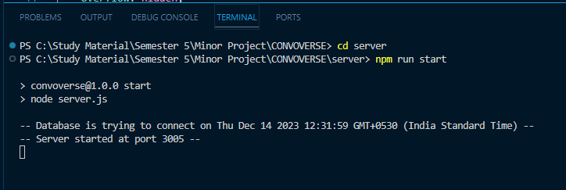

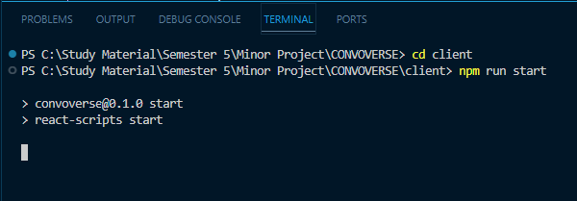

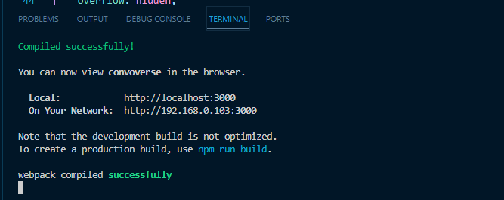

**Login Page**

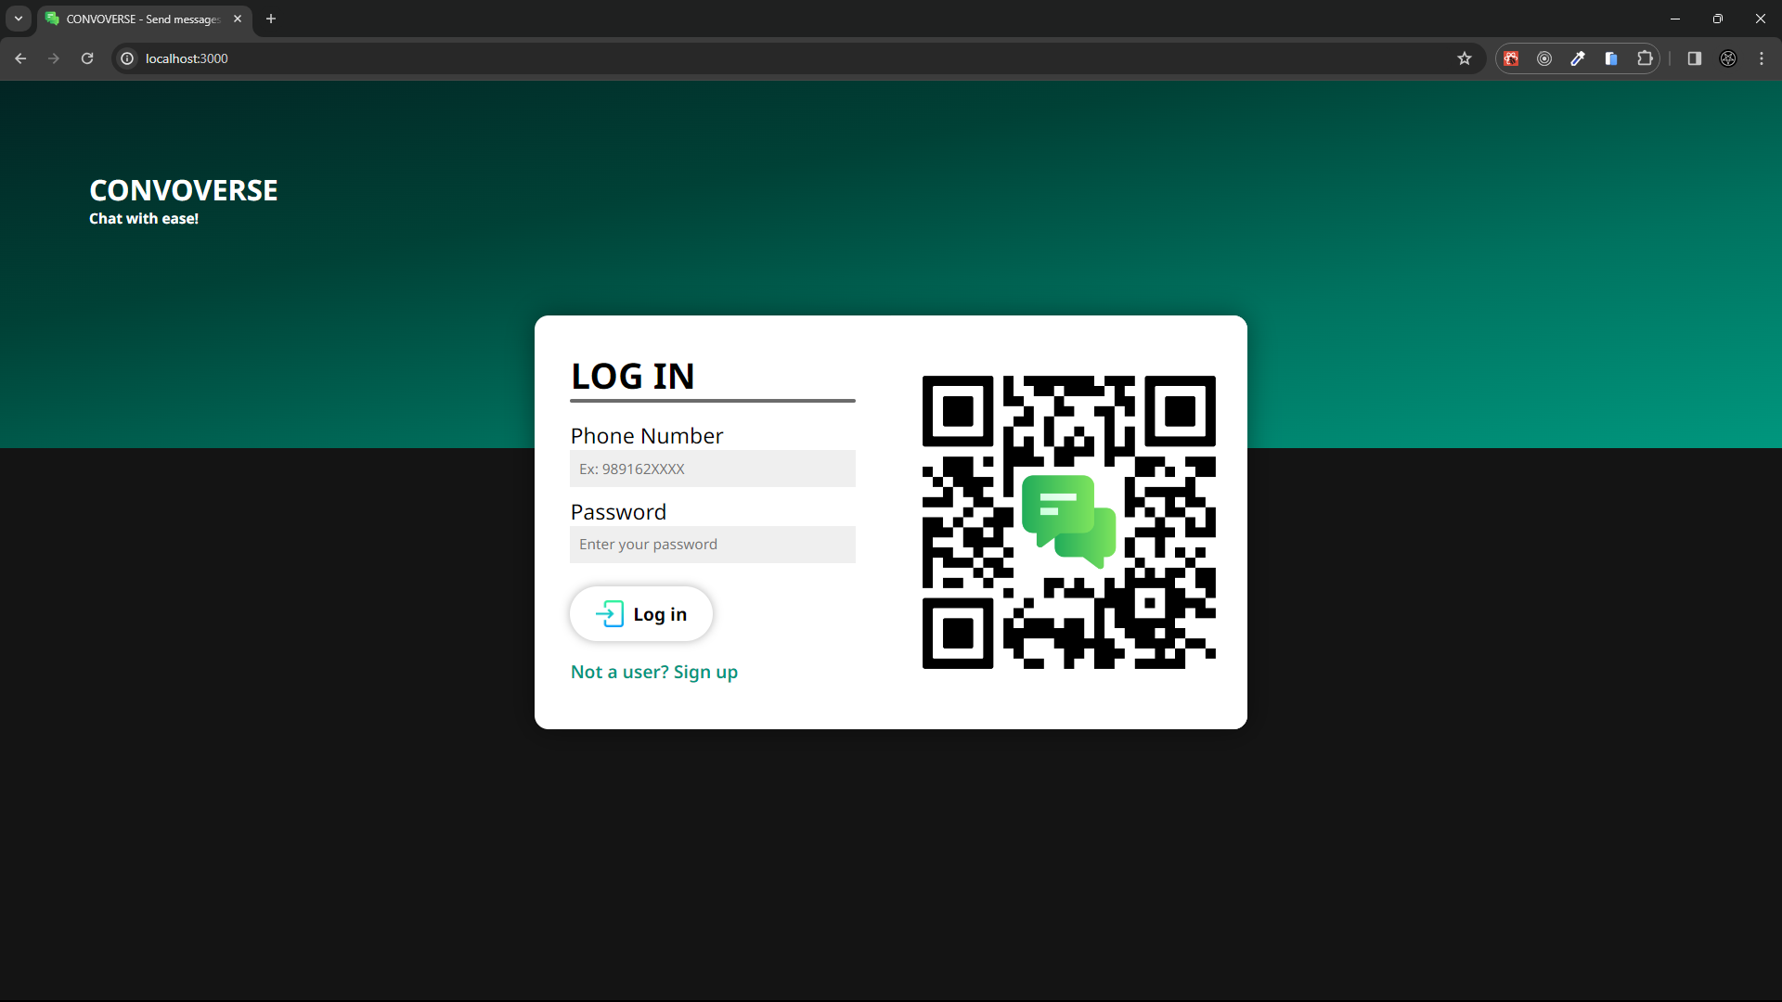

**Signup Page**

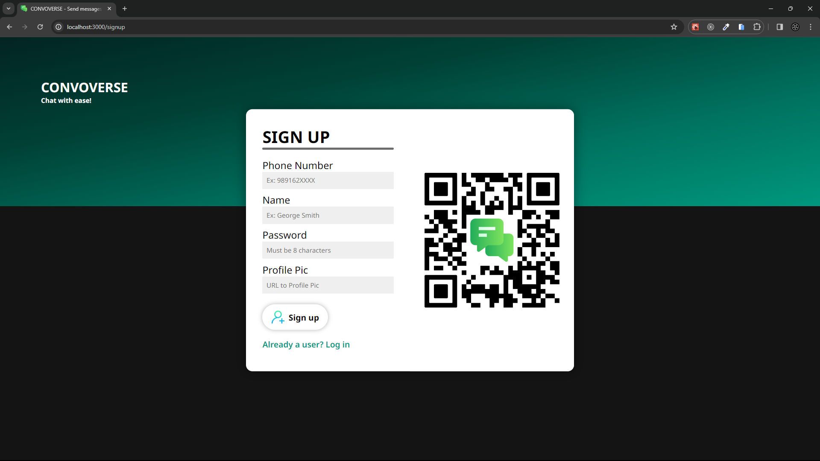

**Home Page**

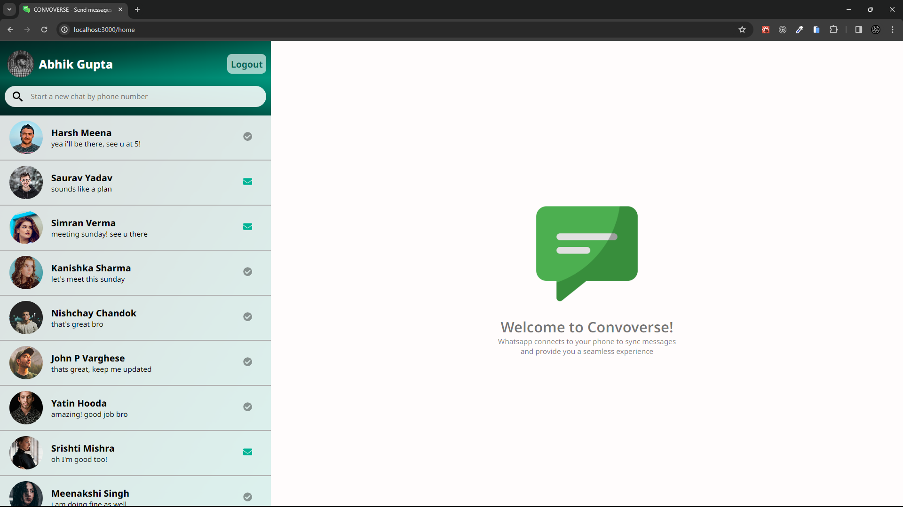

**After opening up a chat**

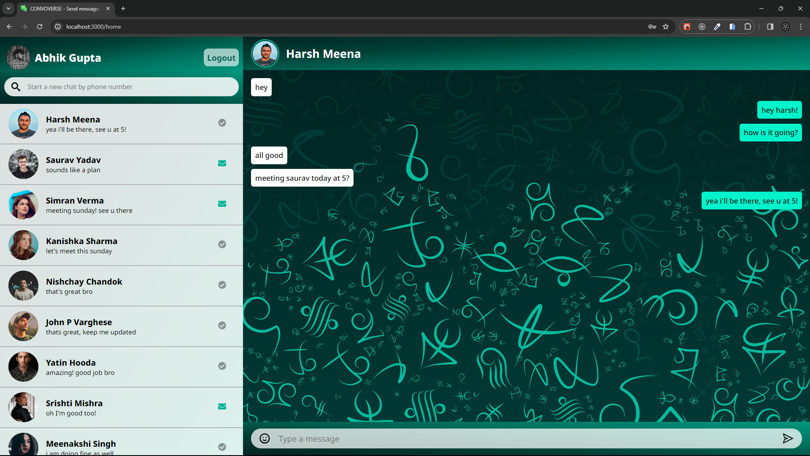

**Writing a new message**

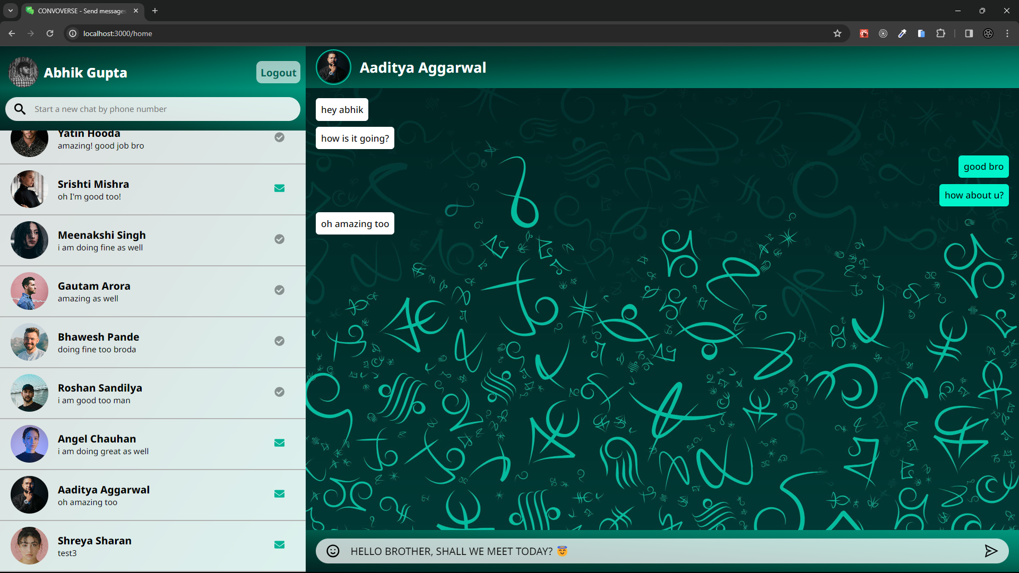

**Sending the new message**

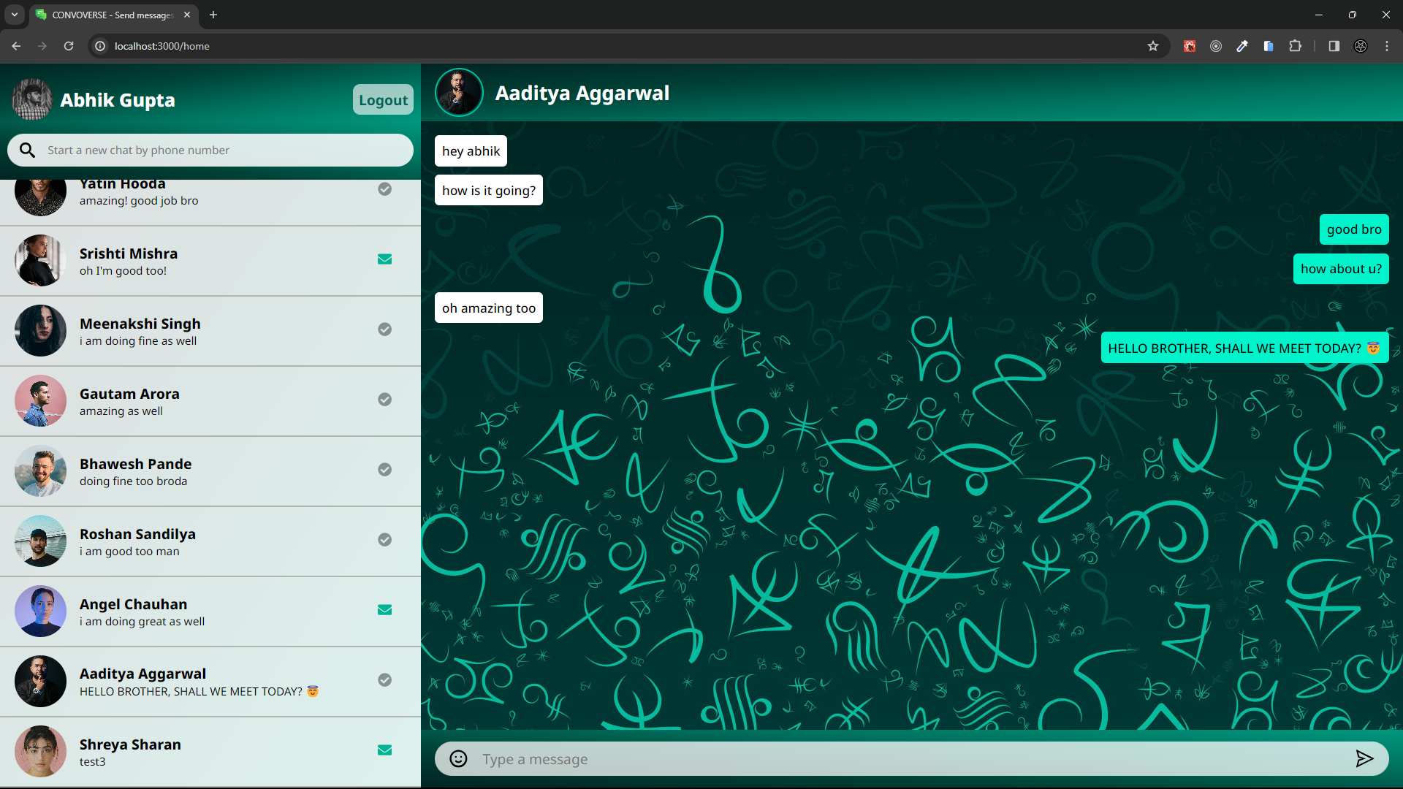

**Searching for a new user**

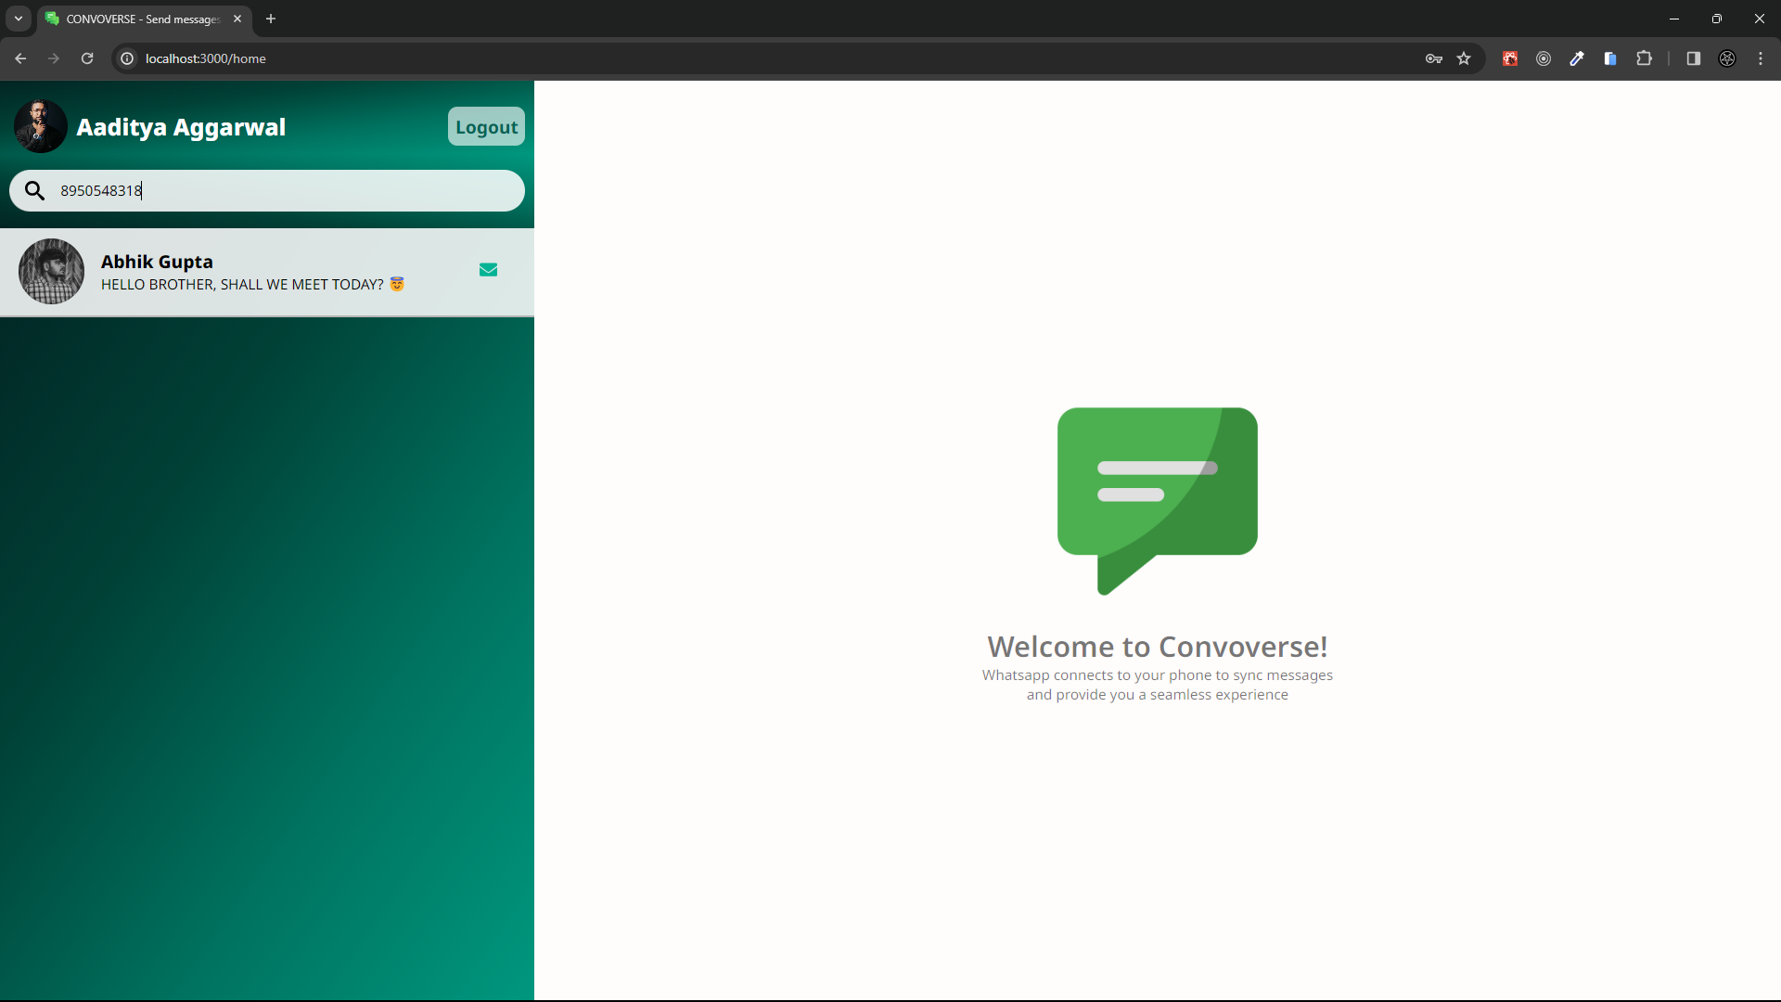

**Creating a new chat**

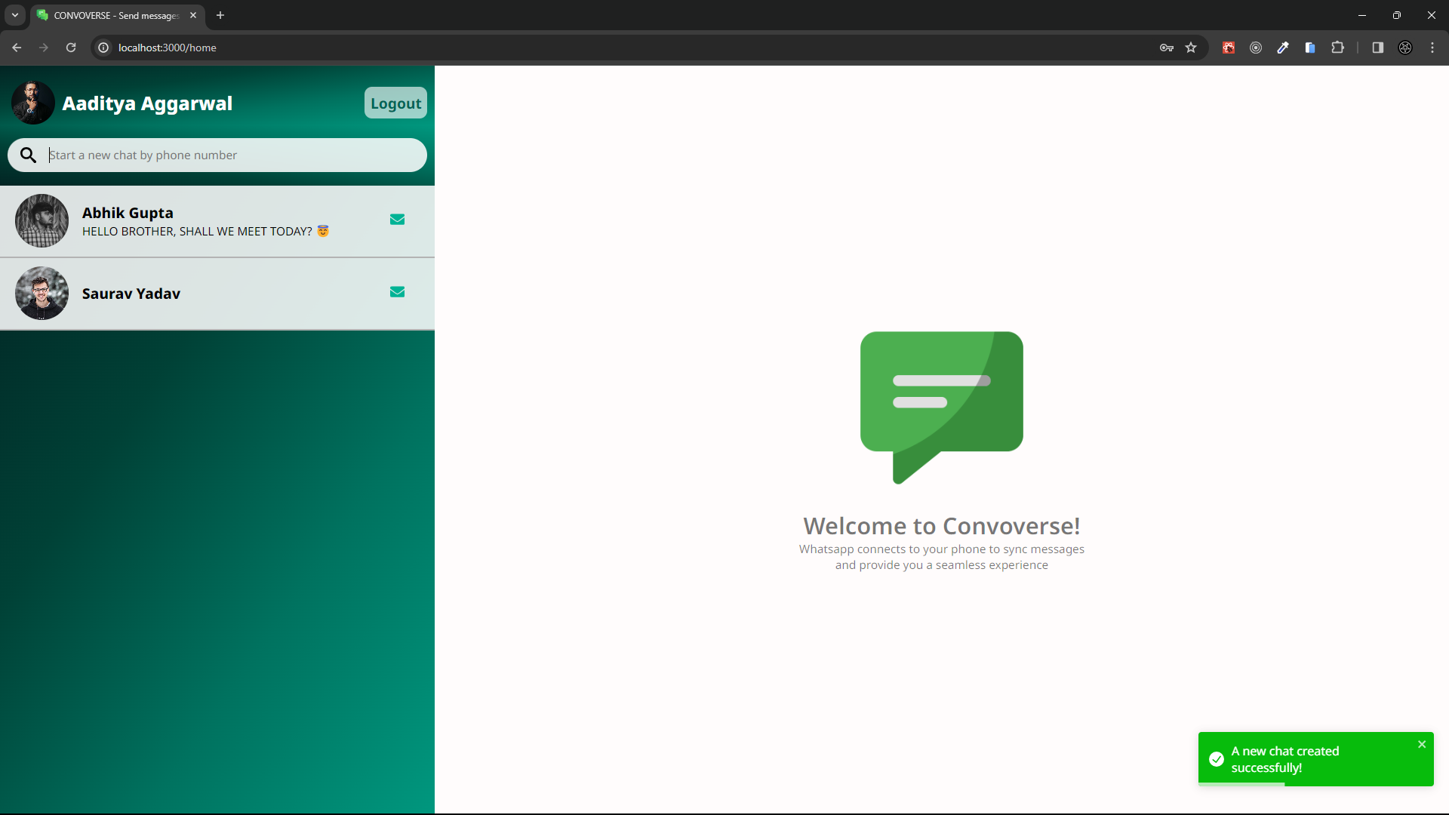

**An empty chat created**

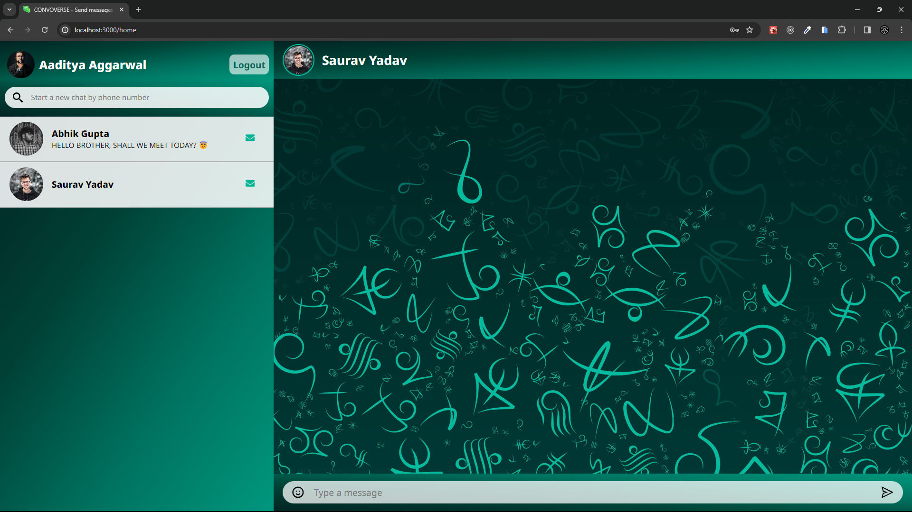

**Logging out**

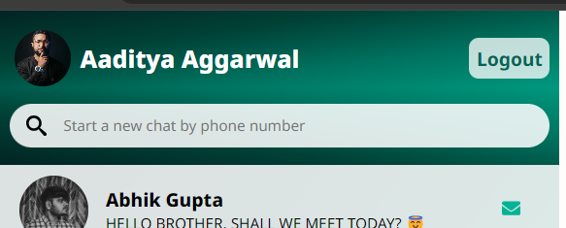 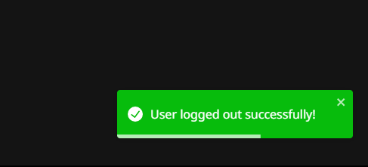

**VERSION CONTROL AND COLLABORATION**

Convoverse, a collaborative effort by Abhik Gupta, Yatin Hooda, John P. Varghese, and Nishchay Chandok, takes the world of chat web applications by storm. Built using the powerful MERN stack, Convoverse provides a seamless and engaging chat experience.

From its humble beginnings as a mock-data-driven frontend in version 1.0, Convoverse has evolved into a fully functional chat platform. The team meticulously crafted each version, adding functionalities and refining the user experience.

Version 2.0 laid the foundation for real-time communication by introducing mock APIs. While conversations weren't happening yet, the infrastructure was in place for future development.

Version 3.0 marked a major turning point. The team implemented the actual controller and API logic, enabling users to send and receive real messages. This version brought Convoverse one step closer to its final form.

The meticulous integration between the frontend and backend took place between version 3.1 and 3.6. This phased approach ensured a smooth and stable integration, avoiding potential complications.

Version 4.0 focused on documentation and code comments. This step was crucial for future maintenance and allowed others to understand the app's inner workings.

Finally, version 5.0 saw the culmination of the team's efforts. This version boasts a polished UI, bug fixes, and enhanced functionality, making Convoverse the user-friendly chat platform it is today.

Convoverse serves as a testament to the power of collaboration and innovation. The team's dedication and perseverance resulted in a compelling chat application that stands out in the digital landscape.

[Visit the Github Repository](https://github.com/abhik2207/CONVOVERSE)

**Our Github Repository**

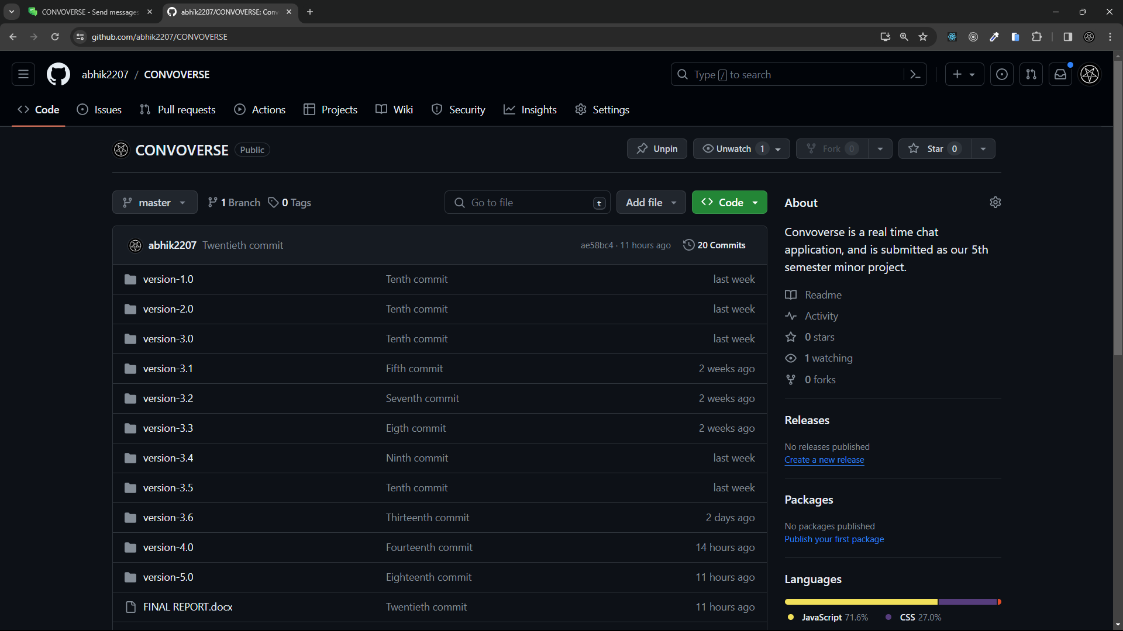

**All collaborators**

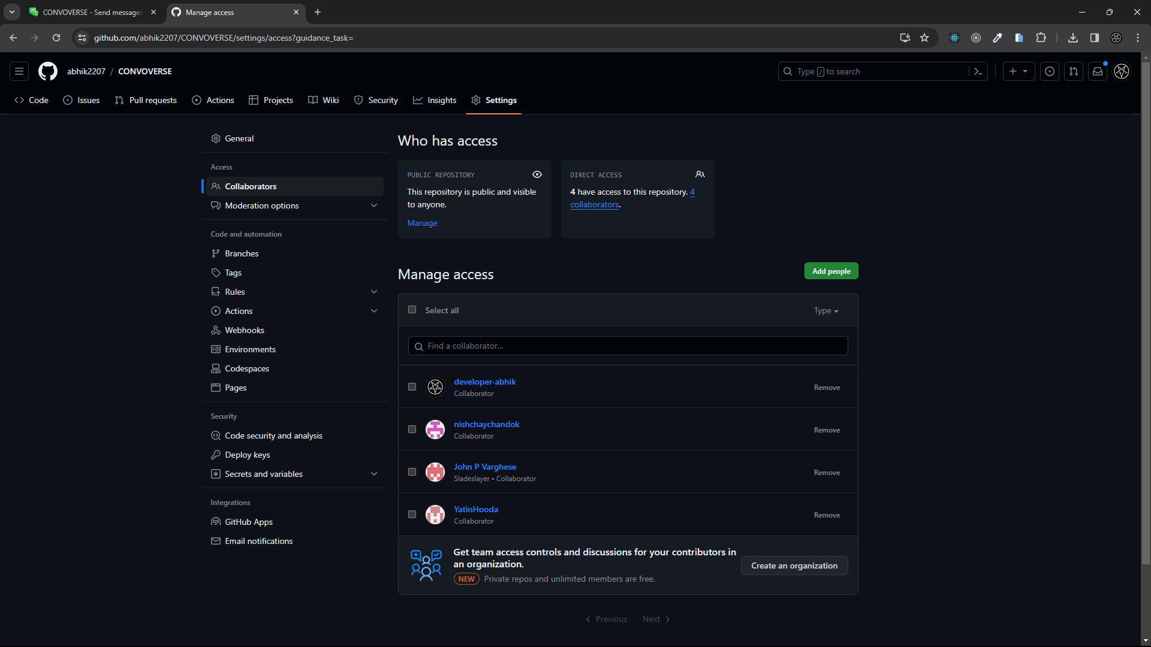

**CONCLUSION**

Throughout the development journey of Vendr, our team has navigated through challenges, embraced innovation, and remained steadfast in our commitment to delivering a premier e-commerce solution. As we reach the culmination of this project, we reflect on the milestones achieved, the lessons learned, and the transformative impact Vendr aims to make in the digital marketplace. From the inception of the idea to the realization of a feature-rich platform, Vendr embodies the collective effort, dedication, and passion of our team.

In the ever-evolving landscape of e-commerce, Vendr stands as a testament to our unwavering pursuit of excellence and our relentless drive to exceed customer expectations. With its user-centric design, seamless functionality, and commitment to security, Vendr sets a new standard for online shopping experiences. Whether it's empowering users to explore a diverse array of products, streamlining order management processes, or providing personalized recommendations, Vendr is poised to revolutionize the way people shop and transact online.

As we embark on the next phase of Vendr's journey, we remain committed to innovation, continuous improvement, and customer satisfaction. Our vision for Vendr extends far beyond its current capabilities, with plans to implement advanced features, expand into new markets, and embrace emerging technologies. With an unwavering dedication to pushing boundaries and exceeding expectations, Vendr is poised to carve its path as a leader in the ever-evolving world of e-commerce, empowering users, delighting customers, and shaping the future of digital commerce.

**FUTURE SCOPE**

In our ongoing pursuit of excellence, Vendr continuously explores avenues for growth and improvement. Looking ahead, we envision a future brimming with innovation and enhanced user experiences. With an unwavering commitment to staying at the forefront of e-commerce trends, we are excited to unveil our ambitious roadmap for future development. Below, we outline our forthcoming enhancements and features, designed to elevate Vendr to new heights of functionality, accessibility, and customer satisfaction.

1. **AI-Powered Recommendations**: Implement artificial intelligence to offer personalized product recommendations based on user behavior, past purchases, and browsing history. This could increase sales and improve customer satisfaction by making the shopping experience more relevant and tailored to individual preferences.
2. **Multi-vendor Marketplace**: Expanding Vendr to support multiple vendors can significantly broaden its scope. This would allow various sellers to register on the platform, list their products, and manage their inventory independently, creating a diverse marketplace for users.
3. **Augmented Reality (AR) Integration**: Develop AR capabilities to allow customers to visualize products in their own environment before making a purchase. This could be particularly useful for items like furniture and home decor, enhancing consumer confidence in their buying decisions.
4. **Expansion to International Markets**: Adapt the platform for international use by incorporating multi language support, multi-currency pricing, and local payment gateways. This expansion would broaden the customer base and increase revenue opportunities.
5. **Mobile Application Development**: Create a dedicated mobile app for Vendr to provide users with a more convenient, fast, and accessible way to shop and manage their accounts from their smartphones, potentially increasing user engagement and sales.
6. **Blockchain for Enhanced Security**: Explore the use of blockchain technology to enhance transaction security and transparency, especially for high-value transactions and to protect against fraud in payment processes and supply chain documentation.
7. **Voice Commerce Integration**: Integrate voice-activated commerce capabilities, allowing users to search for products, place orders, and manage their accounts through voice assistants like Amazon Alexa, Google Assistant, or Apple Siri. This feature could tap into the growing market of users who rely on smart home devices.
8. **Enhanced Analytics and Insights**: Continuously improving analytics capabilities to gather actionable insights into user behavior, sales trends, and market dynamics can inform strategic decision-making and drive business growth. Implementing advanced analytics tools and predictive analytics can unlock valuable insights for optimizing marketing strategies, product offerings, and user experience.
9. **Dynamic Rating System**: In the future, Vendr aims to implement a dynamic rating system to enhance user engagement and provide more accurate product feedback. Currently, the rating system is static, but the plan is to introduce features such as user reviews, star ratings, and real-time feedback mechanisms. This dynamic rating system will enable users to share their experiences, opinions, and insights about products, fostering a vibrant community-driven environment and aiding other shoppers in making informed purchasing decisions.

**REFERENCES**

1. MongoDB: MongoDB. (n.d.). Retrieved from <https://www.mongodb.com/>
2. Express.js: Express.js. (n.d.). Retrieved from <https://expressjs.com/>
3. React.js: React.js. (n.d.). Retrieved from <https://reactjs.org/>
4. Node.js: Node.js. (n.d.). Retrieved from <https://nodejs.org/>
5. Mongoose: Mongoose. (n.d.). Retrieved from <https://mongoosejs.com/>
6. Stack Overflow: Stack Overflow. (n.d.). Retrieved from <https://stackoverflow.com/>
7. ChatGPT: ChatGPT Documentation. (n.d.). Retrieved from <https://platform.openai.com/docs/guides/chat>
8. JavaScript: JavaScript. (n.d.). Retrieved from <https://developer.mozilla.org/en-US/docs/Web/JavaScript>
9. React router dom: React router dom documentation retrieved from <https://reactrouter.com/en/main/start/tutorial>
10. React toastify: React’s toastify library’s documentation retrieved from <https://fkhadra.github.io/react-toastify/introduction/>
11. Styled components: Styled components library’s documentation retrieved from <https://styled-components.com/>
12. React icons: React icons library’s documentation retrieved from <https://react-icons.github.io/react-icons/>